User Manual (Annexure – 5)
User Manual for the Client funds and securities ISIN wise details under Enhances Supervision Module.

Note:- Stock brokers need not upload File – 2 if they are not holding any clients securities with them i.e. in File 1, number of ISIN = 0 for all UCC’s.

Step 1:- Login into the BEFS for submission of details of client funds and securities balances under Enhanced Supervision module. As mentioned in the below screen.
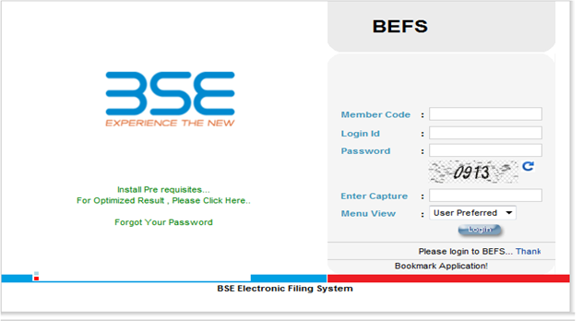

Step 2:- Click on Enhance Supervision – Client funds securities ISIN
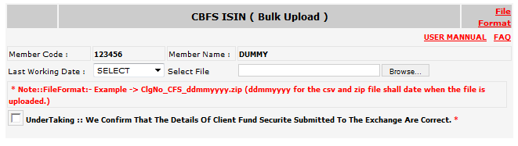
Step 3:- Stock brokers need to upload the file as per format given (i.e. csv – Coma Separated + Zip). Stock broker also need to do the naming convention as given below. File format is also attached as “File format” given in the below print screen.
Stock broker need to browse the file – click on undertaking then - click on upload file.

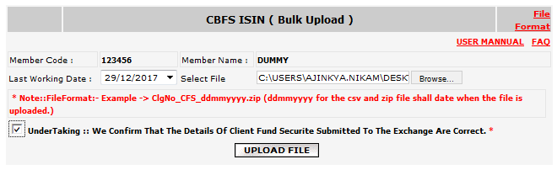

Step 5:- If there is any problem in the file format then system will show an error. Else click on Submit button.
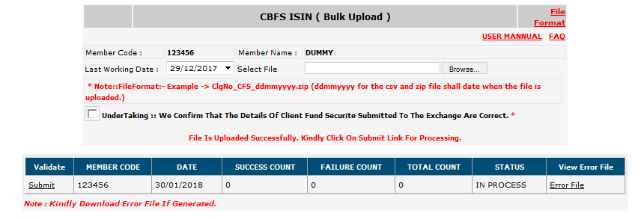
Step 6:- You are requested to verify success count and failure count. If there is “0” failure count then file has been uploaded successfully. However, if there are failure count then stock broker need to view error file and check the reason for the error submission. On verification of the same stock broker need to again upload the file.
On rectification of the same kindly note that only error records need to be uploaded.

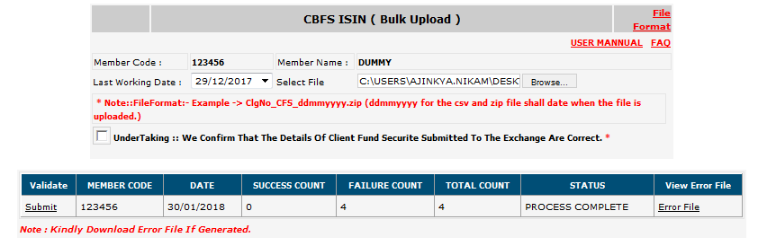
Step 7:- Stock broker can view the data submitted by them in the below mentioned path. i.e. Enhances supervision >> UCC Success Records (ISIN)
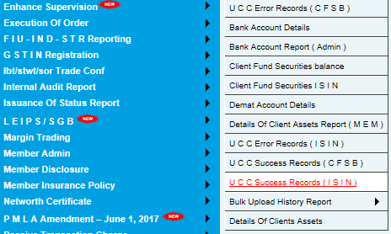
Step 8:- Stock broker can view error file of their last uploaded data only in the below mentioned path: i.e. Enhances supervision >> UCC Error Records (ISIN)
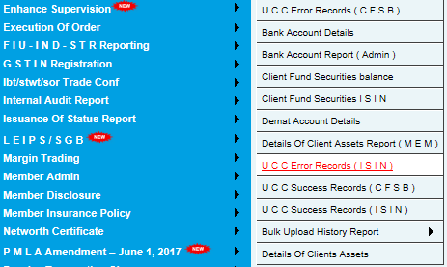
File structure for uploading the data is given as follows:- File format to capture ISIN wise details.
Field Name | BSE Structure | BSE Description
Unique Client Code | As per UCC structure (14 Chars) | As per UCC structure
ISIN | Alpha Numeric  12 Characters | Alpha Numeric  20 Characters
Name of the Securities | Alpha + Numeric + special Character + 200 Character. | Name of the company whose security is held by investor
Quantity of securities ISIN wise | Numeric  20 Numbers (20 digits with 4 decimal points) | Number of securities of the particular ISIN  Number or ‘0’ incase of nil balance
Quantity of securities pledged ISIN wise | Numeric  20 Numbers (20 digits with 4 decimal points) | Number of securities of the particular ISIN  Number or ‘0’ incase of nil balance
Funds raised from Pledging ISIN wise (Rs.) | Numeric (positive upto two decimals), 20 digits(20 digits with 2 decimal points) | Funds raised from the pledging of such securities  Number or ‘0’ incase of nil balance across all Exchanges
Action | 1 Character i.e. A or U or D | A = Addition, U = Update, D = Delete

Stock brokers are requested to ensure:-
- To enter correct ISIN no. & description of the scrip
- Total quantity as per File 1 for the column “Total number of ISINs” has to be same as total sum of count for the column “ISIN” of File 2. (Stock broker- client wise)
- Total quantity as per File 1 for the column “Total quantity of securities” has to be same as total sum for the column “Quantity of securities ISIN wise” of File 2. (Stock broker- client wise)
- Total quantity as per File 1 for the column “Quantity of securities pledged” has to be same as total sum for the column “Quantity of security pledged ISIN wise” of File 2. (Stock broker- client wise)
- Total amount as per File 1 for the column “Funds raised” has to be same as total sum for the column “Funds raised from Pledging ISIN wise (Rs.)” of File 2. (Stock broker- client wise)
- Note that in File 2 UCC and ISIN combination cannot repeat twice. Unless action is U / D.
- In File 2 If stock broker would like to modify (U) or delete (D) the records then validation for the same has to be combination of ISIN and UCC. However, this facility would be available for limited point of time i.e. by 20th calendar day of the month.

