Annexure III
Part A - Guidelines for Bank Balance format
Nomenclature (File Name) | PAN_BA_DDMMYYYY  Explanation:  “PAN” shall be the Member’s PAN (Alpha Numeric 10 characters)  Date shall day of reporting (.eg. Reporting day: 30-01-2023 File name: AABBC1234C_BA_30012023).  Batch/Seq No. starts from 01, in case of multiple files of same week  PAN_BA_DDMMYYYY_01
Frequency of Reporting | Daily basis
Last day of Submission | Members have to submit the data daily (all calendar days) for the previous day except Sunday.  In case of No Holding – Members have to submit Nil reporting/ZERO reporting on the next day.

Revised Bank Balance Format

Bank Account no. | IFSC | Bank Account Type | DD-MM-YYYY

Revised format of Holding statement:

Sr. No. | Field Name | Length (Max) | Description
1 | Bank Account No. | Char(18) | ‘Bank Account No.’ should be as per the reporting done by member under Enhanced supervision=>Bank Account Details.  In case of any new account is opened by the member then member is required to report first in Enhanced supervision.  Member should compulsory use double inverted comma (“) in the beginning & End of every bank account no. For Example –“001020000015”  Value of bank account no. should be Numeric only.
2 | IFSC | Char(11) | ‘IFSC’ shall be as per the reporting done by the member under Enhanced supervision.
3 | Bank Account Type | Number (20) | ‘Bank Account Type’ should be given below –  CLIENT BANK ACCOUNT /SETTLEMENT ACCOUNT/OWN/PROPRIETORY ACCOUNT/ANY OTHER/CONSTITUENT (TM) BANK ACCOUNT
4 | DD-MM-YYYY | Number (20) | Value in Rs. (as per Bank Statement)  Field should not be left blank.  Decimals shall be allowed upto 3 digits  Reporting Date

• File shall be in csv and zip format. One zip file shall contain one csv file only. Naming convention of zip file shall be same as of the csv file.
• In case of success/error file, Members will not be able to upload another file with the same nomenclature. Member may use Batch/Seq No. starts from 01. For Example - PAN_BA_DDMMYYYY _01.
- Files uploaded will be processed for validation check. Members are required to check the “Bank Balances Status Report” window for success/error status of the uploaded file(s). File status will be updated after 30 minutes from the date & time of upload of file.

- In case of error status, members have to correct the data as per the remarks provided in the file and re-upload the entire file with correct data with the different nomenclature.

- In case of non-applicability, members are required to provide a one-time declaration in the system. However, as and when, member becomes eligible for submissions, they will have to submit the data as per the requirements.

- Members are advised to do not upload blank file.

- Members are required to upload bank balances of those Bank Account No.’ s only which has been reported under Enhanced supervision. In case of any new account is opened by the member then member is required to report first in Enhanced supervision.

Part B- User Manual for Bank Balance format

Following are the steps given to upload the Bank Balance

Step 1:
Member Should login into the BEFS Link for uploading the Daily Bank Balance as shown in the below screen. Always login Through Internet Explorer.

UAT :- https://uat.bseindia.in/befs/login.aspx
Production :- https://befs.bseindia.com/login.aspx

Note - Members need to change the password on first time login and then continue UAT.
The Default password B3fs@2023
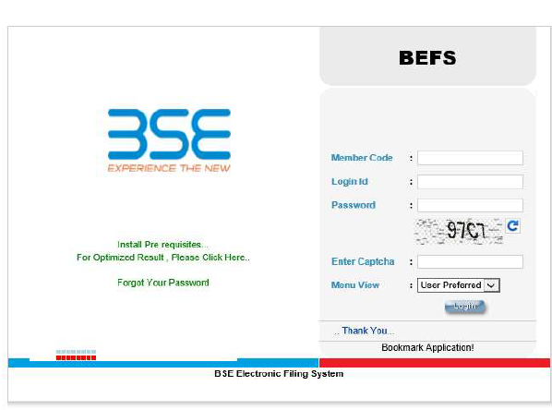
Step 2: Click on Enhance supervision-> Bank Balance >Bank balance Upload
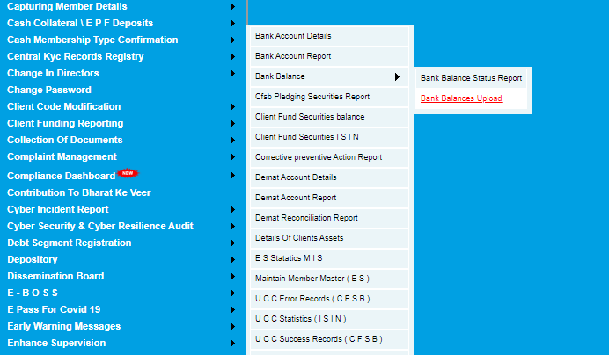
Step 3: Below tab will appear: Select Year, Month & Date for submission
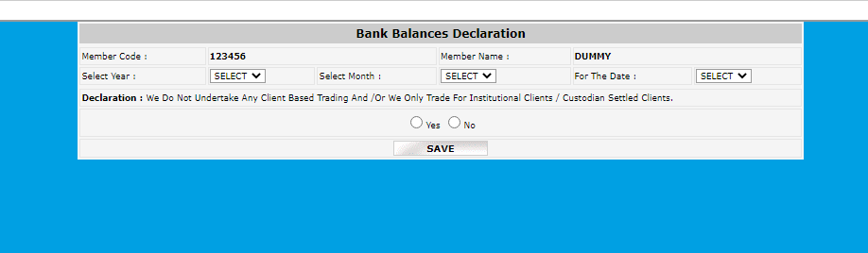

Step 4: Click on “No” to upload file > Click on holding statement bulk upload
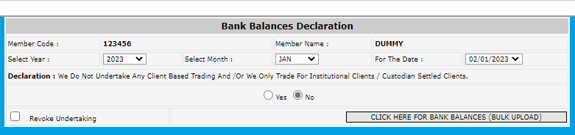
Step 5: Download template for file uploading
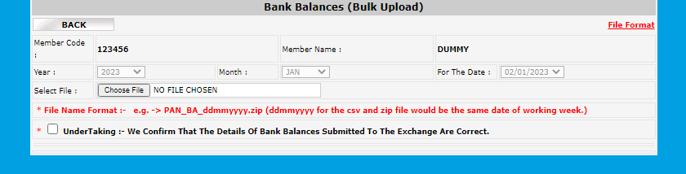
Step 6: Upload file in specified file format .
Step 7:Click on undertaking to confirm submission .

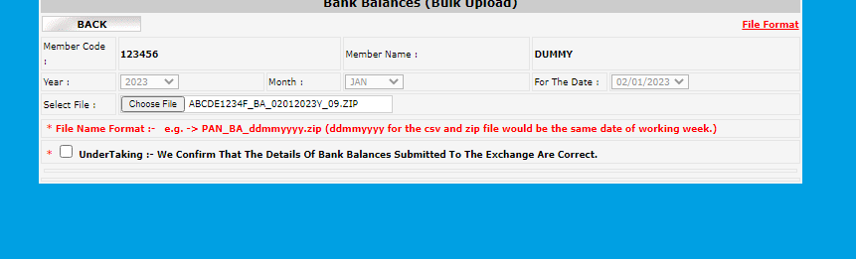

Step 8: After clicking on ‘UPLOAD FILE’, a message “File is Uploaded Successfully” will
appear if the file format is correct.
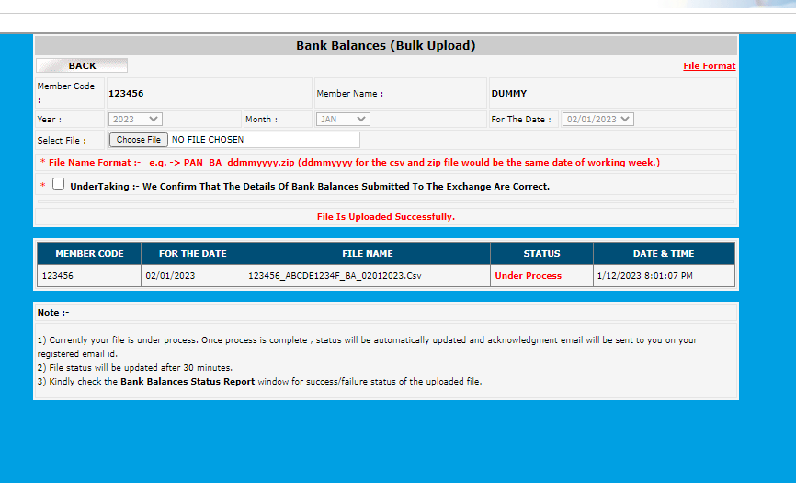

Step 9: Check the File status
Click on Enhance Supervision -> Bank Balance - >Bank Balance Status Report

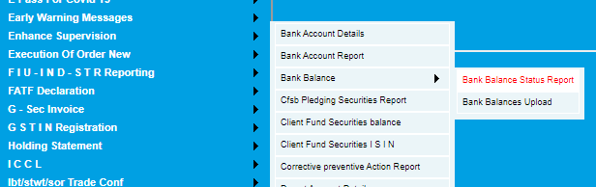
- Always Check the File status while under Process
- If the file is uploaded correctly than status will be shown as “Success”:

- If the file uploaded contains Error than the below message will be the shown in status

