User Manual (Annexure – 6)
User Manual for the Client funds and securities balance report under Enhances Supervision Module.
Step 1:- Login into the BEFS for submission of details of client funds and securities balances under Enhanced Supervision module. As mentioned in the below screen.
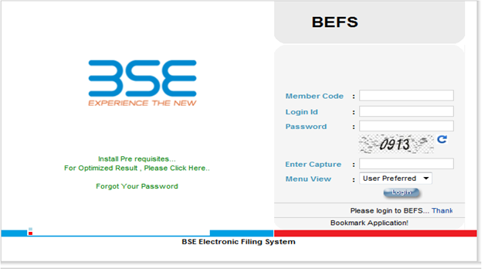

Step 2:- Stock brokers will be required to upload the details of the person who will be handling any queries which will be conveyed to the clients of the stock brokers.
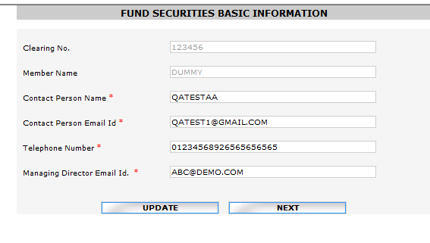
Step 3:- Click on Enhance Supervision – Client funds securities balances
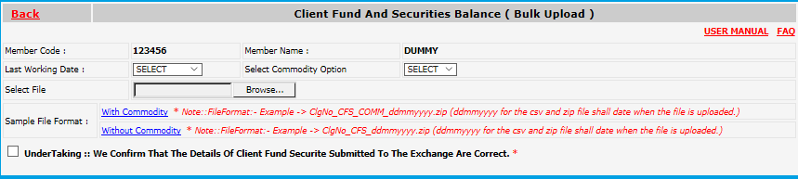

Step 4 : If Stock broker clicks ‘WITH’ for ‘Commodity Segment Option’, the data being uploaded is to be in format provided in template ‘Clg No._CFS_COMM_ddmmyyyy.zip’. If Stock broker clicks ‘WITHOUT’ the data being uploaded is to be in format provided in template ‘Clg No._CFS_ddmmyyyy.zip’.
Stock brokers need to upload the file as per format given (i.e. csv – Coma Separated + Zip). Stock broker also need to do the naming convention as given below. File format is also attached as “File format” given in the below print screen.
Stock broker need to browse the file – click on undertaking then - click on upload file.
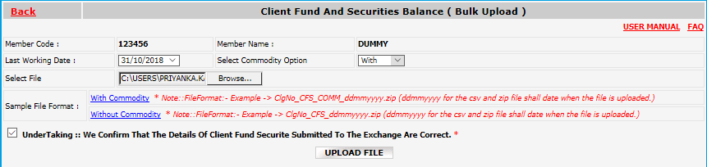

Step 5:- If there is any problem in the file format then system will show an error.
Else click on Submit button.

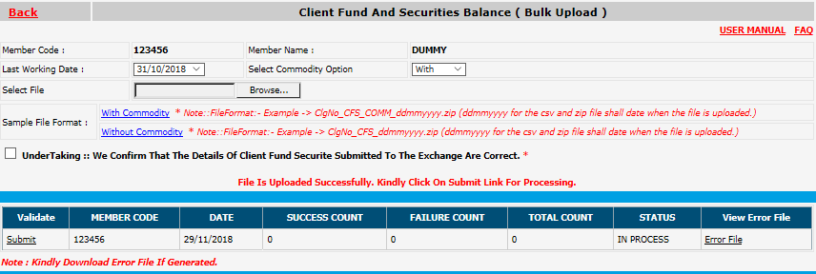

Step 6:- You are requested to verify success count and failure count. If there is “0” failure count then file has been uploaded successfully. However, if there are failure count then stock broker need to view error file and check the reason for the error submission. On verification of the same stock broker need to again upload the file.
On rectification of the same kindly note that only error records need to be uploaded.
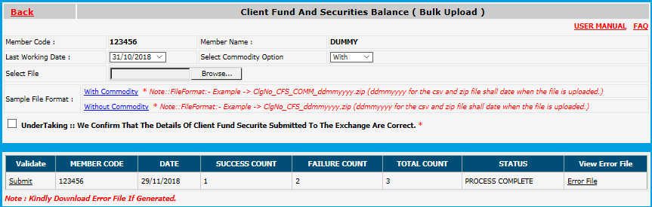

Step 7:- Stock broker can view the data submitted by them in the below mentioned path. i.e. Enhances supervision >> UCC Success Records (CFSB).
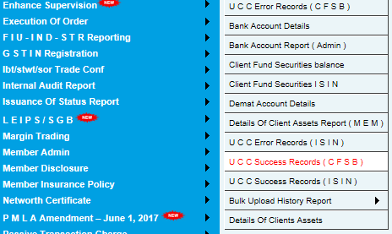

Step 8:- Stock broker can view error file of their last uploaded data only in the below mentioned path: i.e. Enhances supervision >> UCC Error Records (CFSB).
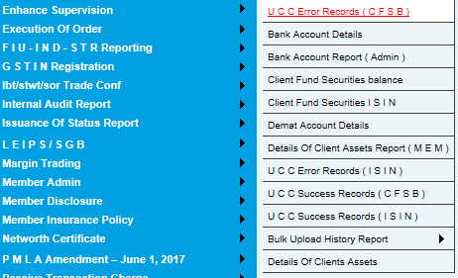

File structure for uploading the data is given as follows:- File format of existing consolidate file with addition of one column viz. Total number of ISINs pledged.
Field Name | BSE Structure | BSE Description
Client Name | As per UCC | As per UCC
Unique Client Code | As per UCC (14 Chars) | Code linked to the PAN details of the respective client
Client PAN no | Alpha Numeric, 10 Characters | PAN no. of the investor
Client Email id | Alpha Numeric, 100 Characters | Email Id of the investor
Client mobile number | Numeric, Min 10 & Max 15 Characters | Mobile number of investor
Fund balance (BSE) (Rs.) | Numeric, 20 digits, Prefix (-) in case of debit. (20 digits with 2 decimal points) | Exchange-wise end of day fund balance as per the client ledger, consolidated across all segments  Should be positive number in case of credit balance and negative (-) number in case of debit balance
Balance Net across Exchanges (Rs.) | Numeric, 20 digits, Prefix (-) in case of debit. (20 digits with 2 decimal points) | Net funds payable or receivable by the broker to/from the client across all Exchanges
Total number of ISINs | Numeric, 20 digits | Sum of ISINs for a client  Number or ‘0’ in case of nil balance across all Exchanges
Total quantity of securities | Numeric, 20 digits (20 digits with 4 decimal points) | Number of securities across all ISINs Number or ‘0’ in case of nil balance across all Exchanges
Total number of ISINs pledged | Numeric, 20 digits | Sum of ISINs pledged for a client Number or ‘0’ in case of nil balance
Quantity of securities pledged | Numeric, 20 digits (20 digits with 4 decimal points) | For every client, number of securities pledged  Number or ‘0’ in case of nil balance across all Exchanges
Funds raised (Against securities pledged) | Numeric (positive up to two decimals), 20 digits (20 digits with 2 decimal points) | Funds raised from the pledging of such securities  Number or ‘0’ in case of nil balance across all Exchanges
Total number of Commodities | Numeric + 20 Numbers  Numeric > 0 | Sum of Commodities for a client  Number or ‘0’ in case of nil balance across all Exchanges
Total number commodities Pledge | Numeric + 20 Numbers  Total number commodities Pledge < Total number of Commodities  Numeric > 0 | For every client, sum of Commodities pledged for a client Number or ‘0’ in case of nil balance
Fund Raised-Commodities (Rs.) | Numeric + 17 numbers and 2 decimals  Value will be > 0 | Funds raised from the pledging of such securities  Number or ‘0’ in case of nil balance across all Exchanges
Last balance settlement date | DD-MM-YYYY  DD/MM/YYYY  DD-MMM-YY  DD/MMM/YY, ND, NA, BTB | 10 Characters, (NA in case settlement of the client is not due, ND is case settlement of clients is not done, BTB in case Bill to Bill)
Action | 1 Character i.e. A or U or D | A = Addition, U = Update, D = Delete

File structure for uploading the data is given as follows:-

