
Private & Confidential – For Private Circulation Only
(This Shelf Information Memorandum is neither a Prospectus
nor a Statement in Lieu of Prospectus)

(Originally Incorporated as Bharat Hotels Limited on January 22, 1981 as Public Ltd. Company)

Registered Office: Barakhamba Lane, New Delhi 110 001, India
Corporate Office: Barakhamba Avenue, Connaught Place New Delhi - 110 001, India
Tel: +91 11 4444 7777 Fax: +91 11 4444 1234, Website: www.thelalit.com
Contact Person: Mr. V.K. Verma, Senior Vice President & Company Secretary;
Mr. Madhav Sikka, Senior Vice President Finance & Systems;
Email: vkverma@thelalit.com; msikka@thelalit.com

PRIVATE PLACEMENT OF 400 SECURED REDEEMABLE NON-CONVERTIBLE DEBENTURES OF RS. 10,00,000/- EACH FOR CASH AT PAR AGGREGATING RS. 40 CRORE IN ONE OR MORE TRANCHES

GENERAL RISKS:
For taking an investment decision, investors must rely on their own examination of the Issue and the Information Memorandum including the risks involved. The Issue has not been recommended or approved by Securities and Exchange Board of India (SEBI) nor does SEBI guarantee the accuracy or adequacy of this Information Memorandum.

CREDIT RATING:
“CARE A+” (pronounced CARE single A Plus) by CARE Limited for Rs. 140 crores long term NCDs indicating “adequate safety for timely servicing of debt obligations. Such instruments carry low credit risk”.

The rating is not a recommendation to buy, sell or hold securities and investors should take their own decision. The rating may be subject to revision or withdrawal at any time by the assigning rating agency and each rating should be evaluated independently of any other rating. The rating obtained is subject to revision at any point of time in the future. The rating agencies have a right to suspend, withdraw the rating at any time on the basis of new information etc.

LISTING:
The Debentures are proposed to be listed on the Wholesale Debt Market (WDM) segment of the Bombay Stock Exchange Limited (“BSE” or the “Stock Exchange”).

REGISTRAR TO THE ISSUE: | TRUSTEE TO THE ISSUE:
Karvy Computershare Private Limited  Plot no: 17 to 24, Vittal Rao Nagar  Madhapur, Hyderabad 500081  Tel :+91-40-23420815-20  Fax:+91-40-23420814  Email: mailmanager@karvy.com | IL&FS Trust Company Limited  The IL&FS Financial Centre,  Plot C -22, G Block, Bandra Kurla Complex,  Fax No. (022) 26533297  Website: www.itclindia.com
This schedule under SEBI guidelines dated June 6, 2008 for private placement is neither a prospectus nor a statement in lieu of prospectus and does not constitute an offer to the public generally to subscribe for or otherwise acquire the Debentures to be issued by the Issuer.

I. NAME, ADDRESS & REGISTERED OFFICE OF THE COMPANY

SUMMARY INFORMATION OF OUR COMPANY

Name: Bharat Hotels Ltd.

Registered Office: Barakhamba Lane, New Delhi 110 001, India
Corporate Office: Barakhamba Avenue, Connaught Place New Delhi - 110 001, India

II. NAME ADDRESS AND OTHER DETAILS OF DIRECTORS ON BOARD AS ON October 31, 2008

The Board of Directors currently consists of 12 Directors, 8 of whom are non-executive. Out of the total 12 Directors, 6 are independent as per existing provisions of Clause 49 of the statutory listing agreement. The Chairperson of the Company is an Executive Chairperson. The following table sets forth information on the Company's Directors, their designation, residential address and date of appointment.

S.No. | Name of Director | Designation | Address | Date of Appointment
1 | Ms. Jyotsna Suri | Chairperson & Managing Director | N-119, Panchsheel Park  New Delhi - 110 017 | Jan 01, 1989
2 | Mr. Ramesh Suri | Non-Executive Director | N-119, Panchsheel Park  New Delhi - 110 017 | Jan. 22, 1981
3. | Ms.Divya Suri Singh | Executive Director | N-119, Panchsheel Park  New Delhi - 110 017 | Aug.26,2009
4. | Ms.Deeksha Suri | Executive Director | N-119, Panchsheel Park  New Delhi - 110 017 | Aug.26,2009
5. | Mr.Keshav Suri | Executive Director | N-119, Panchsheel Park  New Delhi - 110 017 | Aug.26,2009
6 | Mr. Hanuwant Singh | Independent Non-Executive Director | 6, Panchsheel Marg  New Delhi-110021 | April 26, 1982
7 | Mr. Dharam Veer Batra | Independent Non-Executive Director | W-11, Greater Kailash-II  New Delhi - 110 048 | Nov. 13, 1987
8 | Mr. Abhay N. Firodia | Independent Non-Executive Director | Sanmitra, 132-B/2-A  Ganesh Khund Road  Pune – 411 007 | Nov. 13, 1987
9 | Mr. Chakor L. Doshi | Independent Non-Executive Director | Neela House, 2nd Floor  Dahanukar Marg  Mumbai 400 026 | Nov. 13, 1987
10 | Mr. Lalit Bhasin | Non-Executive Director | 10, Hailey Road  New Delhi-110001 | Feb. 19, 1988
11 | Mr. Vinod Khanna | Independent Non-Executive Director | 13-C, IL Pillazo  Malabar Hills  Mumbai - 400 006 | Sept. 06, 2004
12 | Dr. M.Y. Khan | Independent Non-Executive Director | S-378, Panchsheel Park  New Delhi –110 017 | Dec. 22, 2005

III. SUMMARY OF BUSINESS/ ACTIVITIES

OVERVIEW
Bharat Hotels Ltd (BHL) is a major player in India’s tourism and hotel sector and operates through its premier brand ‘The Grand’.

The Company was incorporated as Bharat Hotels Limited, a public company limited by shares, in New Delhi, India under the Companies Act on January 22, 1981. BHL is registered with the Registrar of Companies in New Delhi and has approximately, 3000 employees as at March 31, 2009.

BHL and its subsidiaries presently operate seven luxury hotels in India’s major cities offering 1,478 rooms in the five-star deluxe segment. All the hotels are operated under ‘The LaLit’ banner. These include:
- The Lalit in New Delhi,
- InterContinental The Lalit Mumbai,
- The Lalit Grand Place Srinagar
- InterContinental The Lalit Goa Resort
- The Lalit Ashok Bangalore
- The Lalit Laxmi Vilas Palace Udaipur
- The Lalit Temple View Khajuraho

In the next three Financial years the company expects to open luxury hotels in Ahmedabad, Bakel, Jaipur, Kolkata, Chandigarh, Noida, Amritsar, Dubai and Koh Samui (Thailand).

BHL’s first venture was Lalit New Delhi, a 457-room five-star deluxe hotel located in the center of India’s capital city, which commenced operations in October 1988. The next venture was the 112 room The Lalit Grand Palace Srinagar. Formerly the palace residence of the Maharajas and one of India’s leading heritage resort hotels, it is located in the mountainous North Indian State of Jammu & Kashmir. BHL’s other two properties are new developments and include the 255-room luxury resort in Goa, InterContinental The Lalit Resort Goa, and the 369 room super deluxe hotel, InterContinental The Lalit Mumbai, in India’s commercial center Mumbai.

On November 30, 2001, BHL agreed to operate and manage the Hotel Ashok in Bangalore on a lease and management agreement from the Indian Tourism Development Corporation, under approval of the Government of India. The hotel has since been re-branded as The Lalit Ashok Bangalore. In 2002, the Company successfully bid for two more Indian Tourism Development Corporation properties under the Government of India’s disinvestments scheme. These properties are the 55-room Laxmi Vilas Palace in Uaipur, which now operates as The Lalit Laxmi Vilas Palace Udaipur, and a 48 room property in the temple town of Khajuraho, Madhya Pradesh, which was re-branded as The Lalit Temple View Khajuraho. In November 2005, BHL successfully bid for the prestigious 165-year-old ‘Great Eastern Kolkata’ and expects to re-commission it after restoration by June-2010 as The Lalit Great Eastern Kolkata.

The following chart illustrates BHL’s current and projected room inventory:
Location | No. of Rooms
Existing Hotels
Top of Form  The Lalit New Delhi | 457
InterContinental The Lalit Mumbai | 369
The Lalit Ashok Bangalore | 183
InterContinental The Lalit Goa Resort | 255
The Lalit Grand Palace Srinagar | 112
The Lalit Laxmi Vilas Palace Udaipur | 55
The Lalit Temple View Khajuraho | 47
Sub Total | 1478
Planned Additions
The Lalit Great Eastern Kolkata | 244
Top of Form  The Lalit Resort & Spa Bekal (Kerala) | 45
The Lalit Ahmedabad | 231
The Lalit Chandigarh | 232
The Lalit Jaipur | 232
The Lalit Noida | 250
The Lalit Amritsar | 200
Overseas Projects
The Lalit Resort & Spa Koh Samui (Thailand) | 100
Top of Form  The Lalit Grand Fort Dubai | 293
Sub Total | 1827
Total | 3305

The Company was listed on the BSE on November 4, 1984, on the DSE on November, 16, 1984 and on the NSE on May 10, 2000. Subsequently, as the holdings of the promoter group exceeded 90% of the total issued capital of the Company, the Company voluntarily de-listed from the DSE, BSE and NSE in June 2003.

Brief Financial Highlights for last 4 financial years is as under:
Rs. Crores
Particulars | FY 2006 (Audited) | FY 2007 (Audited) | FY 2008  (Audited) | FY 2009  (Audited) | FY 2010  (Proj)
Share Capital | 71.89 | 71.89 | 75.99 | 75.99 | 75.99
Reserves | 311.50 | 406.94 | 623.02 | 888.30 | 944.91
Net Worth | 383.39 | 478.83 | 699.02 | 964.29 | 1020.90
Total Debt | 94.30 | 212.03 | 210.08 | 371.32 | 466.68
Net Block | 355.66 | 448.53 | 529.77 | 1016.21 | 1187.70
Net Sales | 279.92 | 378.68 | 431.68 | 340.92 | 400.00
PBT | 67.35 | 157.03 | 119.97 | 45.48 | 65.51
PAT | 51.21 | 104.34 | 70.49* | 28.71* | 65.51*
* Decline in PAT during FY 2008 was primarily due to ‘depreciation write back for earlier years’ amounting to Rs. 40.59 crores during FY 2007.In addition, Rs. 8.02 crores was provided for ‘depreciation for earlier years’ during FY 2008, thereby further reducing the PAT for FY 2008. The company had incurred one time renovation expenses plus rebranding expenses of approx Rs 60.25 crores during FY09 and plans to incur Rs 25 crores on one time renovation expenses during FY 2010, thereby impacting the PAT.

INDUSTRY OVERVIEW
Over the last few years, Indian hotels have consistently delivered high performance. Occupancy levels have consistently improved, along with strengthening of average room rates across the board. These factors indicate a high demand and have acted as eye openers for the global players for their perception about the Indian market potential.

Investors are upbeat on the Indian hospitality market, and the industry is witnessing the entry of non-traditional hotel players like real estate and pharmaceuticals, Sun Apollo, Walton Street Capital, Starwood Capital, Merrill Lynch, Westbridge companies. Year 2006 witnessed entry of key international players from the Middle East like Emaar, Kingdom Hotel Investments, Al Rostamani Group, Al Ghurair Group in India. Also international fund companies like Blackstone, Morgan StanleyCapital and Dawnay, Day Group solidified their interest in the hospitality sector. A common trend witnessed with each of these investments, has been a tie up with Indian real estate developers with either offloading of equity, or in some cases a joint venture. Indian companies including traditional hospitality and real estate companies with hotel portfolios, have welcomed these investments which have infused the much-needed funds for the expansions in the sector. A proactive stance taken by the central government in relaxing the norms stipulated for FDI into the real estate sector has helped in facilitating these developments.

Taking cue from the overseas fund houses' optimistic attitude towards investments in India, international hotel companies like InterContinental, Accor, Starwood and Movenpick have also shed their inhibitions about investing in the Indian market, and are doing so with nearly 26 per cent of the total project costs on certain hotel projects. While the leisure hotel segment coupled with mixed-use development has been attracting interest and investments, the budget segment (better known as the nofrills segment) have also garnered equal interest.

While the government has been extremely proactive in making land available for development of tourism and hotel related projects, they too have decided to ride the real estate wave and set its reserve price at astounding values. Surprisingly though, recent auctions have found takers willing to invest in these properties at relatively high valuations.

Budget segment hotels are also witnessing increased interest, with numerous Indian companies including Taj, Sarovar, Kamats, Oberoi and Lemon Tree planning investments in the segment. Also international chains including Accor, InterContinental, Marriott, Hilton, Wyndham, Choice and Starwood are exploring feasibility of bringing in their low budget brands like Formule I, Holiday Inn Express, Courtyard, Super 8, Sleep Inn and Element. It is estimated that USD 11.41 billion is expected to be invested in the Hospitality sector in the next two years and that India is likely to have around 40 international hotel brands by 2011.

Demand Drivers
The growth rate of tourist flow in India is 8.21% (CAGR), while the foreign exchange earned per tourist is growing at 5.71%. It has been observed that nearly 60% is spent on hotel stay, 25% on travel and remaining on other expenditures. The average duration of stay for foreign tourist in India is 16.9 days. The expenditure by tourist per person per visit has gone up from US$1148 in 1999- 2000 to US$ 1600 2006 – 2007.

The growth in domestic travelers has increased the focus on budget hotels as the average expenditure per person is Rs.2,600 in 2007-08. Religious tourism still constitutes the largest movement of travellers within India. The average stay period for domestic travelers is 2 to 3 days.

Hospitality sector in important Tier I cities also benefit from MICE segment that is growing at 15% per annum. India share of international conventions is only 1.0%, in terms of delegate arrivals. The total revenues from this segment are between Rs.4,000 & Rs.5,500 crores annually. Hotels accounted for 49% of the conventions held in India in 2006-07. The average size of the conference or convention is 226 delegates. Metros along with four top Tier II cities account for 70% of the entire MICE segment in India. The growth of corporate India and many international companies setting up their units in India, MICE has significantly contributed both to occupancy levels and F&B revenues. Pharma and medical companies contribute to 38% of the total revenues generated in this segment. Most of these are held in the period of September to January. Delhi and Mumbai are the most preferred locations for the MICE segment followed by Chennai, Bangalore, Hyderabad and Goa.

Emerging segments in hospitality segment include medical tourism and spa tourism. While medical tourism is mostly composed of tourists from the west, spa tourism growth has been due to increased spending in the segment by domestic travelers. Survey by the International Spa Organisation reveals that the domestic spa tourism has increased phenomenally by 250% in 2007-2008, whereas the outbound numbers have dipped by 50% since 2005. Spa tourism is popular among the demographic segment which is aged between 35-40 years. India’s medical tourism market is growing at a rate of 25% annually and is expected to become a USD 2.0 billion business segment by 2012. To encourage the inflow of medical tourists to India, the government has introduced a new category of medical visas.

Supply
The supply of hotel rooms in India has been very low compared to that of other important cities in Asia. The number of rooms available per 1000 tourist in India in major cities averages around 2.0 while in most Asian cities it is between 3.0 and 4.6.

The supply of 4 star, 5 star and 5 star deluxe segment hotels in India has been historically lesser than other cities in Asia. The following is the supply of the hotel rooms in the above segments across Asia:

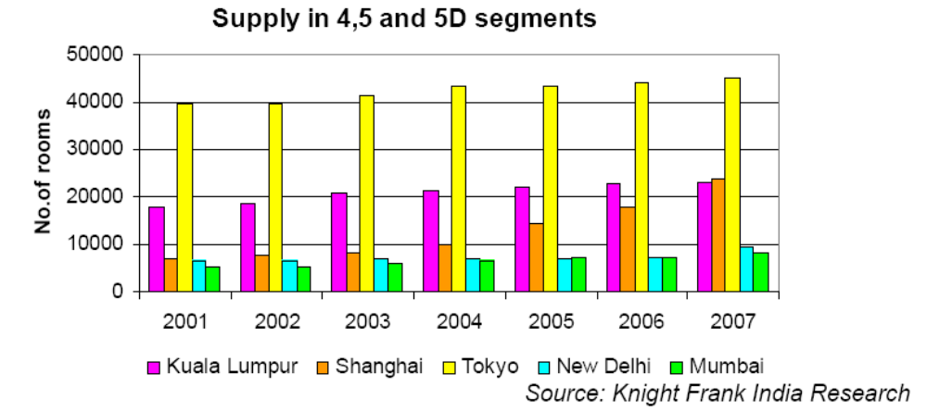

The supply in the premium hotel segment has been low in the key Indian cities when compared to the other cities in Asia. Financial hubs like Hong Kong, Singapore and Tokyo each have more hotels than Mumbai and New Delhi put together. Shanghai has witnessed growth of 19.38% over the last 7 years while the growths in the cities of Mumbai, New Delhi are 6.96% and 5.67% respectively. The growth of hotels in Shanghai has been complemented with the growth in occupancy levels which are as high as 80% in 2007 for peak season and 72% for the off-season period.

Special Regulations for the Hotel Industry

Statutory
Under the FEMA, payments by companies engaged in the hotel industry under franchise agreements or similar collaboration agreements with foreign parties that are above the following limits require special permission of the Government of India:

- 3% of the capital cost of a project (for the construction of a hotel) towards technical and consultancy services, including fees for architects design, supervision etc.;

- 3% of the net turnover towards franchising and marketing or publicity support fees; and 10% of the gross operating profit towards management fee, including incentive fee.

In order to make payments beyond these limits, special permission has to be obtained from the Government of India.

Tourism Policy of the Government of India
Under the Tourism Policy of the Government of India, hotels may, at their option, obtain classification in a star category by applying to the Ministry of Tourism, Government of India. The HRACC assesses the hotel based on various criteria including the quality of facilities provided at the hotel. Upon the hotel obtaining the qualifying mark prescribed for a particular status of star classification, and based on a recommendation of the HRACC, the hotel is given the relevant star classification by the Ministry of Tourism, Government of India

BUSINESS OF THE COMPANY

Brief History and Corporate Profile
Bharat Hotels Limited has been promoted by the Suri family. Mr. Lalit Suri was the Chairperson-cum-Managing Director. Mr. Suri was a Member of Parliament, Upper House and was also the President of The Hotel Association of India. He was a global member of the renowned World Travel & Tourism Council and the Chairperson of the WTTC – India Initiative. The current Chairperson-cum-Managing Director is Mrs. Jyotsna Suri. Bharat Hotels is also involved in tourism related activities along with policy making decisions of various associations and the Government.

Important Events in the History of the Company Some Key Events:

Date | Event
April 1982 | The Company obtained a license from the NDMC for 30,000 square metres plot of land (“Licensed Plot”) on Barakhamba Lane, New Delhi. Under the license agreement the Company was given permission to construct a five star hotel and a multi-storeyed shopping-cum-commercial complex.
October 20, 1988 | Hotel on the Licensed Plot, now known as InterContinental The Grand New Delhi commenced operations.
April 1995 | The Company took over a land in Mumbai by acquiring the entire shareholding of Malbros Hotels Limited.
June 23, 1995 | The Company entered into an agreement with Deeksha Holding Limited for operation of the hotel now known as the InterContinental The Grand Resort, Goa.
July – October 1996 | Malbros Hotels Limited merged into the Company pursuant to a scheme of amalgamation approved by the High Court of Delhi on July 25, 1996 and by the High Court of Bombay on October 10, 1996.
January 19, 1998 | The Company bought the entire shareholding of Jyoti Limited, a company registered in the state of Jammu and Kashmir and having a hotel in Srinagar under a 99-year lease dated November 22, 1997. This hotel is currently operating under the name “The Lalit Grand Palace Hotel”.
November 29, 2001 | The Company entered into an agreement with the Kumarakruppa Frontier Hotels Private Limited under which the business of the latter including all its assets, liabilities and contracts relating to the Ashok Hotel, Banglore were transferred to the Company along with a license for the hotel premises. The hotel is currently run under the name the ‘The Lalit Ashok, Banglore’.
February 26, 2002 | The Company acquired the shares of Udaipur Hotels Limited from the Government of India in a competitive bid. The Udaipur Hotels Limited owns the Grand Laxmi Vilas Palace, a heritage hotel situated in Udaipur, Rajasthan.
August 7, 2002 | The Company acquired the shares of Khajuraho Hotels Limited from the Government of India and the ITDC in a competitive bid. The Khajuraho Hotels Limited owns the Grand Temple View, a hotel situated in Khajuraho, Madhya Pradesh.
April 2003 | InterContinental The Grand Resort in Goa commenced operations.
August 2003 | InterContinental The Grand in Mumbai commenced operations.
February, 2004 | The Company had entered into a license agreement for Land for 30 years with Bekal Resorts Development Corporation Limited for the purpose of development of resort.
November 30, 2005 | The Company acquired 90% of the shares of Apollo Zipper India Limited from the State Government of West Bengal in a competitive bid. Apollo Zipper India Limited owns the Great Eastern Kolkata, a heritage hotel.
December 31, 2005 | Company acquired land in Ahmedabad to construct a five hotel. Company has acquired additional land in 2008. Hotel shall become operational from September 2011.
March 9, 2006 | Company in JV with DLF, acquired land at the Rajiv Gandhi Information and Technology Park to construct a five star hotel in Chandigarh.
August 19, 2006 | Company acquired land in Jaipur to construct a five hotel. Hotel shall become operational from March 2010.
February 9, 2007 | Company acquired land in Noida to construct a five hotel
May 02, 2007 | Company announced its first overseas project – The Lalit Grand Fort Dubai, in collaboration with Nakheel of UAE. Hotel shall become operational from March 2011.
June 13, 2007 | Company acquired land in Amritsar to construct a five hotel. Hotel will become operational from March 2014.
September 28, 2007 | Khajuraho Hotels Limited amalgamated with the company as per scheme of arrangement approved by order of the Hon’ble High Court. Appointed date of the scheme is April1, 2006.
2008 | The Company entered into a Joint Venture Agreement with the promoters of Bharat Hotels (Thailand) Co. , a company registered under the laws of Thailand for acquiring a Resort at Koh Samui, Thailand. In this Joint venture company the company is holding 89.99% equity making it a subsidiary of the Company.
November 19, 2008 | All hotels were operated under the brand of The Grand – Hotels, Palaces & Resorts till November 19, 2008, when the company re-branded as ‘The Lalit’ for its top line hotels, under The Lalit Suri Hospitality Group.

Details of Hotels owned by the company:

The Lalit, New Delhi
The Lalit, New Delhi is owned and managed by the Company. The New Delhi Municipal Council granted the Company a license for the underlying land for a period of 99 years with effect from March 11, 1981. The license was granted for the construction and commission of a five-star hotel, as well as commercial complexes, which are presently known as the World Trade Tower and the World Trade Center.

This five-star deluxe hotel located at Barakhamba Avenue, Connaught Place, New Delhi, spreads over six acres and is in the center of the city’s premier business and commercial district, Connaught Place. It is located adjacent to shopping centers and office complexes. It is 24 kilometers from the international airport and close to government offices, cultural centres and international trade fair grounds. It is also within close proximity to various historical landmarks.

The property currently has 457 operational rooms. All of the rooms offer all modern facilities and services, including a mini bar, internet access, international satellite broadcast television and direct-dial telephone with international access. The Lalit, New Delhi has eight food and beverage outlets, which include:

Baluchi: serves Indian cuisine.
24/7: offers multi-cuisine dining.
Art Junction: offers light meals.
Woks: offers Chinese and Oriental cuisine.
24/7 Bar: a full service bar.
The Grill: Rooftop restaurant serving European cuisine.

Suitable for a wide variety of occasions, the hotel’s banqueting facilities can accommodate up to 500 guests and the hotel’s garden area can host 800 guests. Quorum, a newly renovated meeting place with boardrooms, is suitable for small meetings and offers facilities such as video conferencing, wireless internet connectivity and multimedia tools. The Quorum also has a private dining area, a library and business center.

The The Lalit, New Delhi also offers an all-season swimming pool, health club, salon and shopping arcade. The adjoining World Trade Tower and World Trade Centre complexes are leased by the Company from the New Delhi Municipal Council. The Company sub-licenses this commercial space pursuant to a number of sub-license agreements with third parties. The hotel is presently under 'phased product upgrade'.

InterContinental The Grand, Mumbai
The Company acquired full ownership of the land on which the Mumbai property is located via a merger with Malbros Hotel Limited in October 1996 and opened the newly constructed InterContinental The Grand Mumbai in August 2003. The property is spread out on eight acres of land and is located near Sahara International Airport at Sahar Airport Road, Mumbai, Maharashtra.

The hotel offers 369 rooms & 21 services apartments. Each room is equipped with modern facilities and services, including international satellite broadcast television, internet access and direct-dial telephone with international access.

The property offers services apartments, which are popular among overseas travelers who stay for longer durations. The service apartments offer a range of facilities including separate living and sleeping areas, a fully equipped kitchen and work space. They also offer the complete range of facilities provided by the hotel such as 24 hours room service and house keeping. InterContinental The Grand Mumbai has six food and beverage outlets:
- 24/7: a multi-cuisine all day dinner
- Baluchi: serving Indian cuisine
- Woks: Chinese cuisine with a noodle bar.
- Trendz: Restaurant serving western cuisine.
- Beluga Bar: a lounge bar with cigar lounge.
- Sutra Bollywood Lounge: bar & nightclub.

The banquet and conferencing facilities incorporate a banquet hall, The Majestic, which can accommodate more than 1,200 persons and two smaller party rooms. The Majestic is equipped with modern, automated conference facilities. The Gardens is available for outdoor functions for upto 2,000 persons. The hotel also provides a business club, health club, outdoor swimming pool, and salon. Adjoining the hotel is a commercial complex, which offers show rooms, offices, service apartments, a movie theatre and a Chinese restaurant.

The Lalit Ashok, Bangalore
The Lalit Ashok Bangalore is operated by the Company pursuant to a lease and management agreement dated November 29, 2001 between the Company and Kumarakruppa Frontier Hotels Private Limited. Kumarakruppa Frontier Hotels Private Limited, a government-owned company, acquired the property pursuant to demerger by the Indian Tourism Development Corporation Limited. Pursuant to the agreement, the Company has the license to operate, modernize and manage the property until March 31, 2032.

The Lalit Ashok Bangalore is located in Bangalore’s main commercial and shopping district at Kumarakrupa High Grounds. The hotel is built on a 10.33 acre site overlooking an 18-hole golf course and has 183 rooms with extensive landscaped gardens. All rooms and suites are appointed with modern facilities, tea/coffee markers, mini-bar, satellite television and international direct dialing telephones. The Grand Ashok Bangalore has four food and beverage outlets:

- 24/7: offering multi cuisine selections.
- Baluchi: serving Indian cuisine.
- Mandarin: Oriental and Chinese cuisine.
- Sutra Bar: the hotel bar.

The Lalit Ashok Bangalore offers extensive banquet facilities, including the Chanakya Hall for receptions, parties and banquets that can accommodate from 500 to 1,000 persons, and a convention hall for parties and receptions up to 200 persons. The hotel offers an outdoor swimming pool, health club, beauty salon and barber shop and tennis courts..

Intercontinental The Grand Resort, Goa.
Deeksha Holding Limited, an affiliate of the Company, granted the Company a license deed for the Goa property for a period of 25 years (plus a 25 year renewal option) with effect from June 23, 1995. The license was granted for the construction and commission of a five-star hotel. The 85 acre property is located between two rivers and fronted by the Arabian Sea an almost a kilometer long beach front in Raj Baga, Canacona, Goa.

The newly constructed InterContinental The Grand Resort Goa was opened by the Company in mid-2003. The hotel comprises of 255 suites. All suites offer modern facilities and conveniences such as satellite television and communication facilities, including data ports with high speed modem lines and two-line telephone connections.

The InterContinental The Grand Resort Goa has six food and beverage outlets:
- Canacona: a 24-hour coffee shop offering Indian and international cuisine.
- The Sea Bq: serving barbeques.
- Sirocco: serving Mediterranean food
- Veri Feni: a sports bar.
- Azebo: pool bar – snacks & beverages.
- Corta’s: situated on the beach, specializing in seafood.

The Braganza ballroom can accommodate approximately 600 persons in theatre style. Two meeting rooms, Vasco and Alfonso, are also available. The resort has three additional meeting rooms and a business center. The resort offers a 9-hole international standard Double ‘T’ Links golf course, fresh and seawater sports facilities, and health and body rejuvenation services. Other facilities include a free form swimming pool, squash and tennis courts and a children’s play area.

InterContinental The Lalit Grand Palace, Srinagar, Kashmir
The InterContinental The Lalit Grand Palace Srinagar is operated by the Company pursuant to a license deed granted by Jyoti Limited, a subsidiary of the Company, for a period of 99 years with effect from February 3, 1998. The license was granted to the Company for the renovation of the property and to commission a five star hotel.

This heritage property was converted as an InterContinental Hotel in April 2001, making it Srinagar’s first international hotel. This heritage resort, nearly a century old, spreads over 25 acres and is located at Gupkar Road, Srinagar, Jammu and Kashmir. The property is 15 kilometers from the airport and close to the city’s key historical attractions. The Lalit Grand Palace Srinagar is ringed by the Himalayan ranges and overlooks the Dal Lake. Formerly the palace residence of the Maharajas, the property has been fully restored and offers 112 palace style rooms. All rooms and suites are equipped with modern facilities and services, including tea/coffee maker, safes, international satellite broadcast television and direct-dial telephones with international access. A business center with modern facilities is available.

InterContinental The Lalit Grand Palace Srinagar has five food and beverage outlets:
- The Chinar: open 24 hours a day.
- The Durbar Hall: Formal dining.
- The Outdoor Bar-be-Que
- Dal Bar: a full service bar
- The drawing room and The Billiards Lounge: a games lounge and bar.

The Durbar Hall, along with two banquet rooms, can accommodate up to 200 guests. The Palace’s gardens can accommodate outdoor functions of over 1,000 persons. Leisure amenities include an indoor heated swimming pool, a health club with gym, sauna, steam, whirlpool and massage, a beauty salon and barber shop and a shopping arcade, along with tennis courts, a putting green, walking lawns with nearby surroundings ideal for cycling, trekking, fishing and photography. Guests also have access to two adjoining international standard golf courses including a nine-hole golf course and a 18 hole course.

The Lalit Laxmi Vilas Palace, Udaipur
The Company’s subsidiary, Udaipur Hotels Limited, owns and operates the Lalit Laxmi Vilas Palace Udaipur. Udaipur Hotels Limited took over this heritage property from the Indian Tourism Development Corporation under the Government of India’s Disinvestment Scheme in February 2002. This palace property was built in 1911 by Maharana Bhupal Singh and has been carefully restored.

The Airports Authority of India has granted The Lalit Laxmi Vilas Palace (a unit of Bharat Hotels Limited) a non-exclusive license for an airport restaurant at Udaipur Airport. The Parties entered into a license agreement on September 20, 2005 for a period of ten years from October 4, 2005 through October 3, 2015.

The Lalit Laxmi Vilas Palace Hotel is located on the Bank of Fateh Sagar Lake. It offers 55 rooms, which includes suites and palace rooms. In room facilities and services include central air conditioning, attached baths and satellite television. A new wing is currently under construction, which will add an additional 50 rooms to the property.

The Lalit Laxmi Vilas Palace Hotel has two food and beverage outlets:
- Padmini Restaurant: serving continental, Chinese and Indian cuisine.
- Sur Sagar: a full service bar.

The “Aangan” is a multi functional conference hall with a capacity for 120 persons, and the lawn and pool side can accommodate up to 100 persons for outdoor parties and receptions. The hotel offers 23 acres of lawns and the largest outdoor swimming pool in Udaipur.

Overall tourist arrivals in Rajasthan are expected to grow substantially in the coming years with the State Government giving strong impetus to tourism growth.

The Lalit Temple View, Khajuraho.
The Company took over the Lalit Temple View Khajuraho heritage property from the Indian Tourism Development Corporation under the Government of India’s Disinvestment Scheme in August 2002 and owns the property through its subsidiary, Khajuraho Hotels Limited. It was merged with Bharat Hotels w.e.f April 2006. It is a high quality boutique hotel offering 48 rooms and suites, with a range of five-star deluxe facilities and services. It is a member of Small Luxury Hotels of the World. Located six kilometers from the airport and spread over eight acres of land, The Lalit Temple View Khajuraho is 200 meters from the “Khajuraho Temples”, the main tourist attraction of the temple town.

Material Agreements with Third Parties:

License Agreement with Intercontinental Hotels
The Company has entered into two license agreements with InterContinental Hotels Corporation concerning the Goa and Mumbai properties, respectively, pursuant to which InterContinental has granted the Company non-exclusive licenses to use the InterContinental brand and business practices system for these hotels. Each license agreement provides for the following fees payable to InterContinental during the term of the license:

- License fee of 3% of gross rooms revenue.
- Marketing assessment of 2% of gross rooms revenue
- 5% of reservation revenue.
- Recognition Programme Assessment of 3% of total revenues generated by Priority Club Ambassador Programme Members.
- Marketing Contribution of US$10 per 2000 point transaction.

The effective periods of the licenses are as follows:

- Mumbai: April 1, 2004 through December 31, 2013, plus two five-year renewal terms.
- Goa: April 1, 2004 through December 31, 2011, plus two five-year renewal terms.

Pursuant to the terms of the license agreement, the Company has a continuing obligation to ensure that the hotels comply with InterContinental brand standards and to provide any necessary funds required for capital expenditures and upgrading of the properties to ensure such brand standards are maintained. InterContinental may terminate or suspend a license agreement should the Company breach the terms of the license agreement and if such breach is not cured within 30 days of notice from InterContinental. The Company would be in breach if it fails to operate any of the four InterContinental properties in accordance with the InterContinental brand standards.

Sub-Licenses for Shops in the World Trade Center and World Trade Tower, New Delhi.
The Company has entered into a number of sub-license agreements with third parties for sub-licensing of commercial space in the World Trade Center and World Trade Tower. The standard terms of the sub-license agreements provide for a sub-license of office accommodation for a term co-extensive with the term of the license granted to the Company under the original license agreement with the New Delhi Municipal Council, and that the sub-licensee shall pay a security deposit that will be used by the Company to finance the New Delhi hotel complex project.

Expansion Plans:
The Lalit Great Eastern, Kolkata
Presently under restoration and renovation, The Grand Great Eastern Kolkata is expected to reopen by June 2010. It will offer five star deluxe facilities and services, including 244 rooms and suites, four restaurants and bars and the largest conference and banqueting facility in Kolkata. The company took over The Great Eastern Kolkata, a heritage property, under the Government of West Bengal’s Disinvestment Scheme in November 2005 and owns this property through its subsidiary, Apollo Zipper India Limited.

Bekal
BHL has commenced construction of a 45 cottage resort and entered into a license agreement dated January 5, 2004 with BRDCL for the 25.69 acre leasehold property. This property is expected to open by November 2009.

Ahmedabad
The Company has acquired land measuring 21,300 square meters in Ahmedabad for the purpose of setting up a 231-room hotel. This property is expected to open by September 2011.

Chandigarh
Through Prime Cellular, a subsidiary of BHL, the Company plans to develop a 200 room five-star deluxe hotel at the Rajiv Gandhi Information and Technology Park with DLF at a total cost of Rs. 275 crores, of which Prime Cellular is expected to contribute approximately 50%. It is expected that this hotel will become operational by April 2011.

Jaipur
BHL has acquired land on a 99 years lease in Jaipur to construct a 232 rooms five star hotel. The hotel is expected to open in March 2010.

Noida
BHL has acquired land on a 90 years lease in Noida to construct a 250 rooms five star hotel.

Dubai
The company has entered into 50-50% JV with Nakheel to construct and manage a 293 room hotel. The hotel is expected to open April 2011.

Amritsar
BHL has acquired free hold land in Amritsar to construct a five star hotel. The Hotel is expected to open in April 2014

Thailand
The Company has entered into a Joint Venture Agreement with the promoters of Bharat Hotels (Thailand) Co. , a company registered under the laws of Thailand for acquiring a Resort at Koh Samui, Thailand. In this Joint venture company the company is holding 89.99% equity making it a subsidiary of the Company. The Resort is expected to open in April 2014

Strengths of the Company:
The company believes that the following are its primary competitive strengths:

Access to International Markets and Global Best Practices through InterContinental Hotels Corporation Relationship.
InterContinental Hotels Corporation has a world-wide customer base. Through the relationship with IHC, BHL is able to take advantage of this customer base to reach international markets at competitive prices. The IHC reservation network, Holidex Plus, allows the company to change room rates multiple times a day, which enables it to respond to dynamic and changing market demands on geographical and price point levels.

The company is also exposed to global best practices through its relationship with IHC, which have helped to improve standards and achieve cost efficiencies. BHL is able to adapt and apply these standards to all of the hotels in the Grand Group. For example, the company has implemented energy conservation practices that have significantly cut the energy costs, which is among the highest fixed costs in operating a hotel.

Management Expertise
The Company is managed by a team of experienced and professional managers with average senior management experience of nearly two decades in the hotel industry. Additionally, the management has a proven track record in acquiring and turning around second-tier hotels. For example, the management team has successfully converted the Bangalore Udaipur and Khajuraho properties, which were previously perceived not to be of international standard, into well-regarded and profitable properties. The Company is in the process of renovating and restoring the Kolkata properties, as well. The management team has been able to identify attractive acquisition opportunities that, combined with management’s turn-around expertise, shall continue to yield positive results for the Company.

Distinctive Mix of Properties Across India
The Company has a distinctive mix of heritage, resort and business properties spread across India, in such locations as Srinagar and Goa. BHL is one of the few hotel chains in India with properties in four major metro areas (Delhi, Kolkata, Mumbai and Bangalore), and with three heritage properties, the company is also positioned to represent the culture and history of India. The Goa property, an all-suites resort with private beach and golf course, is among the largest resorts in the country. Finally, the recent acquisition of the Kolkata property adds Asia’s oldest hotel to the portfolio of distinctive properties. This 165 year old hotel, called the “Jewel of the East,” was commissioned in 1840 and is said to be India’s first starred hotel. The company believes that their distinctive mix of properties spread across the country gives them access to different categories of customers and provides a distinctive range of offerings targeted at business and leisure travelers alike.

Strong Position in MICE Segment
The company has a strong position in the Meetings, Incentives, Conventions and Events (MICE) segment of the Indian hotel industry. The MICE segment is rapidly growing in significance and the company is well positioned to take advantage of the growth. BHL has the largest banqueting and event facilities in Goa and Bangalore and the second largest in Mumbai. The Srinagar property is the only hotel that has a banqueting facility in that city. All of the banqueting and event facilities are complimented by the other amenities available at the respective hotel properties in which they are situated.

Strong Value Proposition
The company believes that it provides its customers with a superior experience during their stay in its hotels. BHL provides various amenities required by business and leisure travelers at competitive prices. The company seeks to continually identify and develop services which shall enhance value to the customers, strategies to help the company allocate resources efficiently and ways to strengthen its reputation in the Indian hotel industry.

Strategic Alliance:
BHL has a strategic alliance with InterContinental Hotels Corporation, a leading global hospitality group, with more than 3,600 hotels, 539,000 guest rooms and 27 million Priority Club members across nearly 100 countries and territories. Through the relationship with IHC, the company has adopted standard operating procedures, including energy efficient practices, front office practices and human resources practices. Further, the company access to IHC’s distribution network, which has helped to lower our customer acquisition costs, and the company is able to participate in trade fairs utilizing the IHC brand.

Business Strategy:
The Company’s business strategy is to focus on its core business to enhance profitability and optimize returns to its shareholders. The principal components of the Company’s strategy are as follows:

Build Strength and Awareness of the Brand
BHL’s portfolio of hotels were being operated under our umbrella brand, “The Grand Group.” which was changed to a new brand name, “The Lalit” in the end of Nov-08. The Company’s brand vision is to build long-term loyalty and competitive advantage in the global marketplace by positioning “The Lalit Group” as a luxury and lifestyle brand leader. BHL has developed international clientele through its association with IHC, and plans to leverage this exposure to further develop the “The Lalit” name as a prestige brand on the international level. The company is working to accomplish this vision with selective international marketing and by delivering a consistent level of product and service that aims to be excellent, innovative and customer-driven. BHL also intends to maintain a high standard of quality for its guest facilities and services with regular renovation and refurbishment of existing properties.

Expand Presence to Other Major Cities
The company intends to establish its presence with hotels, resorts and palaces in key travel and business destinations in India. By 2010, the company plans to open three additional operational hotels – The lalit Great Eastern Kolkata, The Lalit Resort Bekal and The Lalit Ahmedabad (which will also include a flight catering services facility). BHL also plans to expand its presence in other cities such as Jaipur, NOIDA, Hyderabad, Amritsar, Chandigarh and Chennai. By 2011, the total number of hotel rooms offered by the Company is expected to exceed 3,000.

Build Upon Customer Loyalty
The Company has been making efforts to increase customer loyalty through frequent customer programs, including the Grand Life Program, a frequent diner’s program, and The Grand Connect, a frequent booker’s program. BHL intends to further grow its loyalty program base by developing a guest loyalty program. To support these efforts to build customer loyalty, BHL shall continue to seek to ensure that the personalized elements that draw customers back to its hotels remain strong.

Focus on Developing and Offering Distinctive Products to our Guests
The Company shall continue to focus on providing premium and distinctive products and services to its guests, as the demand for these products within the hotel industry continues to grow, particularly in the premium market. The Company shall continue to seek out and develop such distinctive products intended to enhance customer experiences.

Marketing:
The company has a corporate sales team managing the sales and marketing activities of the entire group of hotels. BHL also has unit and regional sales teams at each of the Delhi, Mumbai and Bangalore properties. The unit sales team is responsible for securing business for the hotel, while the regional sales team is responsible for business opportunities in the entire regional geographical market for all of the hotels in the Lalit Group.

BHL’s main sales and marketing focus has been to maximize system delivery with its sales and reservation network. The company uses Holidex and Trust for reservations for all its Properties and is well connected with the global distribution systems (Amadeus, Galileo, Sabre and World Span) and all internet related reservation. Presently, the company has entered into agreements with over fifty travel agents to offer special rates and charters. BHL has also entered into an agreement with ATP Heatcoat & Associates Ltd representing The Grand Group of Hotels in UK and European Markets. Airline crews are also an important customer category and the company enters into various agreements with different airlines to provide accommodation to their crew, including recent agreements with Air France, All Nippon Airways, Egypt Airlines, and Singapore Airlines. These agreements are for fixed terms, whereby the airlines block and pay in advance for a certain number of rooms.

Insurance
The Company is covered by insurance policies that cover loss of rental, fire, flood, riot, strike, malicious damage, other material damage to property and development sites, business interruption and public liability. The Company believes that its properties are covered by adequate insurance provided by reputable independent insurance companies in India and with commercially reasonable deductibles and limits on coverage.

Intellectual Property
The company owns and uses certain trade and service marks and it has applied for trade and service mark certification for certain marks that are in use. The company has obtained registration of the trademark and logo “The Grand” and “Connaught Plaza” as a service mark in Class 42 under the Trade Marks Act, 1999 (i.e., provision of food and drink, temporary accommodation etc.).

Competition
Competition in the hotel industry in the markets where the Company’s hotels operate is intense. Competition is based primarily on room rates, quality of accommodation, brand recognition, service level, convenience of location and the quality and scope of amenities. The Company’s hotels generally compete with other five-star deluxe hotels in the cities where the Company’s hotels are located.

Government Regulations
The operations of the Company are subject to various laws and regulations in India. The success of the Company’s strategy to expand its existing properties, acquire new properties or to open newlyconstructed properties and hotels is contingent upon, among other things, receipt of all required licenses, permits and authorizations, including local land use permits, building and zoning permits, environmental, health and safety permits and food and liquor licenses. Changes or concessions required by regulatory authorities could also involve significant costs and delay or prevent completion of the construction or opening of a project or could result in the loss of an existing license.

The Company believes that it is in compliance in all material respects with all other government regulations currently in effect. The Company has not experienced significant problems with government regulations with regard to these issues, and is not aware of any pending government legislation that might have a material adverse effect on its property or hotel operations.

Contingent Liability
As at March 31, 2009, the company has following contingent liabilities which have not been provided for in the books of the accounts of the company:
- Income tax related disputes amounting to Rs. 79.25 crores
- Guarantees issued by the banks on behalf of the company & its subsidiaries amounting to Rs. 7.51 crores.
- ESIC claim of Rs. 84, 109/-
- Stamp duty amounting to Rs. 1.89 crores
- Uncalled liability of Rs. 47.98 crores on shares of Bharat Hotels (Thailand) Company Ltd.
- Demand by Custom Authorities against import of aircraft for Rs. 6.68 Crores.

Litigation and other proceedings
The Company and its subsidiaries are not a party to any proceedings that, if determined against the Company and its subsidiaries, would have a material adverse effect on its business and operating results. In view of the merits of the cases, the Company and its subsidiaries have not established reserves in their financial statements to cover the entire amounts of potential liability. Should any new development arise, such as a change in Indian law or a ruling against the Issuer or its subsidiaries by appellate courts or tribunals, the Company or its subsidiaries may need to establish reserves in its financial statements, which could increase its expenses and current liabilities.

Subsidiaries
BHL has six subsidiary companies, Udaipur Hotels Limited, Prima Buildwell Pvt. Ltd., Jyoti Limited, Apollo Zipper India Limited, Prime Cellular Limited and Bharat Hotels (Thailand) Co. Ltd. The following organizational chart shows the holding structure of the Company and its subsidiaries and the properties owned or operated by each;

BHARAT HOTELS LIMITED (BHL)
- Owns & Operates The InterContinental The Grand Mumbai
- Owns & Operates The InterContinental The Grand New Delhi
- Owns & Operates The Grand Temple View Khajuraho
- Operates The Grand Ashok Bangalore under lease & management agreement with Kumarakruppa Frontier Hotels
- Operates The InterContinental The Grand Resort Goa under license granted by Deeksha Holding Ltd, an affiliate of BHL
- Operates commercial complexes adjacent to the Delhi property, airport restaurants & airline catering services in certain cities
Udaipur Hotels Limited  (99.99% held by BHL)  owns and operates The Grand Laxmi Vilas Palace Udaipur |  |  | Prima Buildwell Private Limited  (100% by BHL)  JV partner for The Grand Fort Dubai |  |  | Jyoti Limited  (99.99% held by BHL)  owns The InterContinental The Grand Palace Srinagar, |  |  | Apollo Zipper India Limited  (90% held by BHL, 10% held by Govt of West Bengal)  owns the Grand Eastern Hotel Kolkata |  |  | Prime Cellular Limited  (100% by BHL)  owns 50% Kujjal Builders Pvt. Ltd,, which has a JV with DLF for the The Grand, Chandigarh |  | Bharat Hotels (Thailand) Co. (89.98% by BHL)  JV for Koh Samui resort in Thailand

Udaipur Hotels Private Limited was incorporated on August 23, 2001, and is now known as Udaipur Hotels Limited. The Laxmi Vilas Palace Hotels was transferred to Udaipur Hotels Private Limited, a demerged company of the Indian Tourism Development Corporation. The Company acquired approximately 90% ownership interest in Udaipur Hotels Limited from Indian Tourism Development Corporation and an additional 10% ownership interest from the Indian Hotels Company Ltd.

Prima Buildwell Private Limited is another wholly owned subsidiary of BHL. This company along with one of the group company is having a JV arrangement (50:50) with Nakheel Group of companies in Dubai. Under this JV a 5 star hotel to be known as The Grand Fort Dubai is being constructed & developed, which shall be managed & operated by BHL.

Jyoti Limited was incorporated on January 22, 1964 and has leasehold right for the hotel InterContinental The Grand Palace, Srinagar. Jyoti Limited has licensed the Srinagar property for Operation & Management to the Company for a term of 99 years.

Apollo Zipper India Limited was incorporated on January 20, 2004. The Great Eastern Hotel, Kolkata, 168 years old hotel, was originally owned by the Government of West Bengal. The hotel was subsequently transferred to Apollo Zipper India Limited, a company which was wholly owned by the Government of West Bengal at that time. The company acquired a 90% ownership interest in Apollo Zipper India Limited from the Government of West Bengal.

Prime Cellular Limited is a subsidiary of BHL. Prime Cellular Limited owns 50% of the equity shares capital in Kujjal Builders Private Limited (50:50 JV with DLF group), which has been allotted land at the Rajiv Gandhi Information and Technology Park in Chandigarh. The Company plans to develop a 200 rooms five-star deluxe hotel at this property under the name of The Grand, Chandigarh, which shall be operated by BHL.

During FY 08, the company entered into JV agreement with the promoters of Bharat Hotels (Thailand) co. ltd., a company registered under the laws of Thailand, which is acquiring a Resort at Koh Samui, Thailand. In this JV, BHL is holding 89.988% equity with an investment of approximately Rs. 70 crores.

IV. BRIEF HISTORY OF ISSUER COMPANY SINCE INCORPORATION AND CHANGE IN CAPITAL STRCUTURE

History
The Company was incorporated on January 22, 1981 under the name and style of M/s Bharat Hotels Limited with its registered office initially at 6 Tilak Marg, New Delhi later changed to Barakhamba Lane, New Delhi –110 001, India vide Board resolution dated November 13, 1987. It obtained a certificate of commencement of business from the Registrar of Companies, Delhi and Haryana on May 4, 1981.

The Company had made a public offer of 1,997,010 Equity Shares through a prospectus dated June 8, 1984, pursuant to which the Equity Shares were listed on the BSE and DSE on November 4, 1984 and November 16, 1984, respectively. Subsequently, the Equity Shares of the Company were listed on the NSE with effect from May 10, 2000. On May 23, 1996, the Company made an issue of 2,600,000 Equity Shares against which GDRs were issued. These GDRs were listed on the Luxemburg Stock Exchange on June 4, 1996.

Premium Holdings Limited, one of the Promoter group companies registered in the U.K. and a wholly owned subsidiary of Promoter, Deeksha Holdings Limited, acquired 1,433,332 GDRs representing 82.69% of the GDRs between April 29, 2002 and May 1, 2002. As a result of the said acquisition, the total shareholding of the Promoters and persons acting in concert in the Company rose to 17,127,738 Equity Shares with voting rights and 2,866,664 underlying Equity Shares against GDRs aggregating to 90.30% of the total paid up share capital of the Company and 91.72% of the equity capital carrying voting rights.

Consequently, Deeksha Holdings Limited, made an offer to acquire 2,144,931 Equity Shares comprising of 1,544,929 Equity Shares and 600,002 underlying Equity Shares standing against 300,001 GDRs under the provisions of the Takeover Code through letter of offer dated November 18, 2002 (“Letter of Offer”) at an offer price of Rs. 28 per Equity Share. The Takeover Code Offer was made for the purpose of consolidating the holdings of the Promoters with a view to delist the Equity Shares of the Company in accordance with the then existing Regulation 21(3) of the Takeover Code.

The Takeover Code Offer was made in three phases to shareholders other than Promoters or persons acting in concert as per the Takeover Code, comprising of the first offer, second offer and the final exit offer. The Equity Shares of the Company have been delisted pursuant to the Takeover Code Offer from the BSE, NSE and DSE with effect from June 11, 2003, June 17, 2003 and June 6, 2003 respectively.

Capital Structure of the Company
a) Share Capital as at date of filing of Information Memorandum with BSE is set forth below:
As on October 31, 2009 | Rs. Crores
1. SHARE CAPITAL
A. Authorised Share Capital
10,00,00,000Equity Shares Rs. 10 each | 100.00
B. Issued, Subscribed & Paid up
7,59,91,199 Equity Shares of Rs. 10 each | 75.99

b) Since the present issue is of debt on a private placement basis, which is not convertible into equity, there is no requirement for promoter’s contribution. There is no promoters’ contribution to this Issue, nor is there any reservation for any group company or any other class of persons.
c) The post-issue paid-up share capital shall be the same as pre-issue paid-up share capital, that is Rs. 75,99,11,990. The Debentures being issued under this Issue are not convertible.
d) Share Premium Account as at 31.03.09 –: Rs. 290,63,77,594/-

Shareholding Pattern
Statement showing Shareholding Pattern as on October 31, 2009

Sr. No. | Type of Shareholders | Number of Shares held | Percentage of total  Shares outstanding
1 | Promoters Group and persons acting in concert with the Promoters Group | 53,664,816 | 70.62
2 | Deutsche Bank Trust Company Americas (GDRs) | 10,399,998 | 13.69
3 | Dubai Ventures Limited | 4,100,000 | 5.4
4 | Others | 7,826,385 | 10.29
 | Total | 75,991,199 | 100.00

Changes in Capital Structure
The table below sets forth changes in the issued share capital of the Company.
Date of  Allotment | Number  of Equity  Shares | Face  Value  (Rs.) | Issue  price  (Rs.) | Nature of Allotment | Cumulative  Paid Up  Capital (Rs.)
January 30,  1981 | 70 | 100 | 100 | To Promoter Group | 7,000
July 12,  1982 | 29,909 | 100 | 100 | To Promoter Group | 2,997,900
July 14,  1982 | 15,021 | 100 | 100 | To Promoter Group | 4,500,000
August 21,  1982 | 160 | 100 | 100 | To Promoter Group | 4,516,000
October 22,  1982 | 429,840 | 100 | 100 | To Promoter Group | 47,500,000
November  17, 1982 | 8,700 | 100 | 100 | To Promoter Group | 48,370,000
March 25,  1983 | 96,600 | 100 | 100 | To Promoter Group | 58,030,000
September  19, 1983 | 7,860 | 100 | 100 | To Promoter Group | 58,816,000
November  10, 1983 | 112,139 | 100 | 100 | To Promoter Group | 70,029,900
October 15,  1984 | 1,997,010 | 10* | 10 | Public issue  of Equity  Shares | 90,000,000
May 27,  1991 | 3,500,000 | 10 | 10 | Rights issue | 125,000,000
May 23, 1996 | 2,600,000 | 10 | 262.50 | Issue of GDRs | 151,000,000
November 8,  1996 | 1,500,000 | 10 | Nil | Allotment pursuant to a scheme of amalgamation† | 166,000,000
January 17,  1997 | 5,533,333 | 10 | Nil | Bonus issue of one Equity Share for every three Equity Shares | 221,333,330
August 8,  2003 | 1,830,400 | 10 | 650 | Private placement of Equity Shares | 239,637,330
December  04, 2004 | 47,927,466 | 10 | Nil | Bonus issue of two Equity Shares for every one Equity Share | 718,911,990
12th June, 2007 | 4,100,000 | 10 | 400 | Private placement of Equity Shares | 759,911,990
† A company by the name of Malbros Hotels Limited merged into the Company pursuant to a scheme of amalgamation sanctioned by the High Court of Delhi on July 25, 1996 and Bombay High Court on January 27, 1997. The swap ratio for the merger was 500 Equity Shares for each equity share of Rs. 100 of Malbros Hotels Limited.

*Each equity share of Rs. 100 was sub-divided into 10 Equity Shares vide resolution of the shareholders of the Company dated November 14, 1983.

Issue of Convertible Bonds/Share Warrants
There are no outstanding warrants, options or rights to convert debentures, loans or other instruments into our Equity Shares.

List of Top 10 Shareholders of Equity Shares and No. of Equity Shares held by them (as on October 31, 2009):
Sr. No. | Name of shareholder | Address | Number of Shares Held | %  Shareholding
1. | Deeksha Holding Limited | 401 World Trade Tower  Barakhamba Lane  New Delhi- 110001 | 30,710,301 | 40.41
2. | Deutsche Bank Trust Company Americas (GDRs) | C/O ICICI Bank, SMS  Empire House, 1st Floor  414, Senapati Bapat Marg  Lower Parel, Mumbai-400013 | 10,399,998 | 13.69
3. | Ms. Jyotsna Suri | N-119 Panchsheel Park  New Delhi-110017 | 7,247,538 | 9.54
4. | Responsible Builders Pvt. Limited | 61 Ground Floor  World Trade Centre  Barakhamba Lane,  New Delhi-110001 | 7,106,400 | 9.35
5. | Richmond Enterprises | 5, Westmoreland Place,  London, Sw1v4AB | 5,491,200 | 7.22
6. | Dubai Ventures Ltd. | Emirates Towers Offices  Lavel-38 Sheikh Zayed Road  Po Box 73311 Dubai UAE | 4,100,000 | 5.40
7. | Jyotsna Holding Pvt. Ltd. | 411 World Trade Centre  Barakhamba Lane  New Delhi-110001 | 3,024,039 | 3.98
8. | Mr. Keshav Suri | N-119 Panchsheel Park  New Delhi-110017 | 2,996,133 | 3.94
9. | Mr. Ramesh Suri | N-119 Panchsheel Park  New Delhi-110017 | 1,219,998 | 1.61
10. | Mr. Lalit Suri | N-119 Panchsheel Park  New Delhi-110017 | 884,463 | 1.16

V. SECURITIES TO BE ISSUED AND LISTED UNDER CURRENT DOCUMENT
Under the purview of current document, the Company intends to raise an amount of Rs. 40 crores of Secured Redeemable Non Convertible Debentures.

The Company has a valid rating of CARE A+ (pronounced CARE single A Plus) as per the details given below and the rating letter from the rating agency is enclosed at the end of this document. The detail terms sheet of the proposed debenture issue is given in section XXIII of this document.

CREDIT RATING:
For Secured Redeemable Non Convertible Debentures:

“CARE A+” (pronounced CARE single A Plus) by CARE Limited for Rs. 140 crores long term NCDs indicating “adequate safety for timely servicing of debt obligations. Such instruments carry low credit risk”.

The rating is not a recommendation to buy, sell or hold securities and investors should take their own decision. The rating may be subject to revision or withdrawal at any time by the assigning rating agency and each rating should be evaluated independently of any other rating. The rating obtained is subject to revision at any point of time in the future. The rating agencies have a right to suspend, withdraw the rating at any time on the basis of new information etc.

VI. DETAILS OF THE ISSUE SIZE
The Company proposes to mobilise through private placement of Secured Redeemable Non-Convertible Debentures (NCDs) of the face value of Rs.10,00,000/- each at par aggregating Rs.40 crores.

Summary Term Sheet
Issuer | Bharat Hotels Limited
No. of Debentures | 400
Face Value | Rs. 10,00,000 each
Minimum Subscription | 1 debenture of Rs. 10,00,000 each and in multiple of 1 thereafter
Tenor | Door to door maturity of 6 years with redemption of 20% at the end of 4th year, 40% at the end of 5th year and 40% at the end of 6th year.
Coupon Rate | 11.5% p.a. payable semi-annually*
Annualised Yield | 11.83% p.a.
Interest Reset | Not applicable
Put/Call Option | Not applicable
Listing | The debentures are proposed to be listed on the WDM segment of the Bombay Stock Exchange Limited (BSE)
Issuance | The Debentures are proposed to be issued in Dematerialised form
Trading | The Debentures will be traded in Dematerialised form only
Depository | NSDL/CDSL
Security | The Debentures shall be secured by first pari-passu mortgage and charge on certain immoveable and moveable assets with minimum asset cover of 1.33 of the outstanding NCDs at all times
Security Creation | The security shall be created in favour of the Trustees within 180 Days from the Deemed Date of Allotment or such extended period as may be permitted by the relevant authority (ies).
Rating | CARE A+ (pronounced CARE single A Plus)
Settlement | Payment of interest will be made by way of cheque(s)/ interest warrant(s)/ demand draft(s)/credit through RTGS system
Issue Open Date | November 16, 2009
Issue Closing Date | November 16, 2009
Pay In Date | November 16, 2009
Deemed Date of Allotment | November 16, 2009
*Subject to TDS at applicable rate

The Company reserves the right to change the issue programme and also accept or reject any application in part or in full without assigning any reason.

VII. DETAIL OF UTILISATION OF PROCEEDS OBJECTS OF THE ISSUE

The Present issue of Debenture is being made to meet the normal capital expenditure, general corporate purposes and long term working capital requirement.

The Main Object Clause of the Memorandum of association of the Company enables it to undertake the activities for which the funds are being raised through the present issue and also the activities which the Company has been carrying on till date. The proceeds of this Issue after meeting all expenses of the Issue will be used by the Company for meeting issue objects.

The Issue proceeds are not being raised for the purpose of any specific or identified project. Thus, there has been no appraisal.

VIII. MATERIAL CONTRACTS INVOLVING FINANCIAL OBLIGATION

The following contracts not being contracts entered into in the ordinary course of business carried on by the Company or entered into more than two years before the date of this document which are or may be deemed material have been entered or to be entered into by the Company.
These material contracts, and material documents referred to hereunder, may be inspected at the Registered Office of our Company between 10.00 am to 4.00 pm on working days.

Material Contracts

Copy of consent letter from IL&FS Trust Company Limited agreeing to act as Trustee to the Issue.

Material Documents
  - Certified true copies of the Memorandum and Articles of Association of the Company, as amended from time to time.

  - Copy of the Certificate of Incorporation of the Company dated 22nd January 1981

  - Certified true copy of the Resolution(s) of the Company passed at the General Meeting held on 9th August 2001 for increase in borrowing limits.

  - Certified true copy of the Resolution of the Board of Directors for issuance of debentures and empowering for other related matters.

  - Copies of Annual Reports of our Company for the last five financial years.

  - Certified true copy of the Resolution of the Members of the Company passed at the Extra Ordinary General Meeting appointing S.R. Batliboi & Associates as statutory auditors of the Company.

  - Copy of tripartite agreement between the Company, Karvy Computershare Private Limited and National Securities Depository Limited.

  - Copy of tripartite agreement between the Company, Karvy Computershare Private Limited and Central Depository Services (India) Limited.

DETAILS OF PAST BORROWINGS

The Company and its subsidiaries have obtained various financial facilities from banks which include working capital demand loans, cash credits, bank guarantees and a letter of credit issuance facility, short-term loans, corporate loans and non-convertible debentures. As at 31st August, 2009, borrowings from banks and institutions were:
Particulars | Outstanding (Rs./ in crores)
Secured | 346.03
Unsecured | 39.91

The table below sets forth outstanding borrowing of the Company as on August 31, 2009:
Secured
Debentures |  | Rs. Crores
(i) |  |  | 100.00-
 |  |  |  | -
Term Loans
(i) | From Financial Institutions |  | 6.00
(ii) | From Banks
 | (a) In Rupees |  | 231.47
 | (b) In Foreign Currency
(iii) | From Others
 |  |  |  | 337.47
Working Capital Loans
From Banks:
(i) | For Working Capital
 | In Rupees |  | 8.56
(ii) | For Overseas Works
 |  |  |  | 8.56
Short Term loans
From Banks:
(i) | For Working Capital
 | In Rupees |  | -
(ii) | For Overseas Works |  | -
 |  |  |  | -
Advances from Clients:
From Government Departments, Public Sector Undertakings & Others - Secured against hypothecation of Construction Material and Plant & Machinery
(i) | Interest Bearing |  | -
(ii) | Non Interest Bearing |  | -
 |  |  |  | -

Un Secured
Foreign Currency Convertible Bonds |  |  | -
 |  |  |  | -
Foreign Currency Loans from Banks [ECB] |  |  | -
 |  |  |  | -
Debentures:
(i) |  |  | -
 |  |  |  | -
Short Term Loans from Banks
[i] | From Financial Institutions |  | -
[ii] | From Banks |  | 39.91
[iii] | From Others |  | -
 | [Repayable within one year – Rs------ Lakhs (Previous Year Rs.------Lakhs)] |  |  | 39.91-
Sales Tax Deferment Loan |  |  | -
 | [Repayable within one year – Rs------ Lakhs (Previous Year Rs.------Lakhs)] |  |  | -
Bills Discounting |  |  | -
 | [Repayable within one year - Rs.------/- Lakhs (Previous Year Rs------Lakhs)] |  |  | -
Fixed Deposit Scheme |  |  | -
 | [Repayable within one year – Rs----- Lakhs (Previous Year Rs.-------- Lakhs)] |  |  | -
Deposits [from Stockists & Sales Promoters]
 | Public Deposit & Others |  | -
 |  |  |  | -
 | Total |  | 385.93 | 385.93

Details of Security for Secured Indebtness : (Rs. Crs.)
Name | Sanctioned Amount | Amount Outstanding | Repayment Schedule | Security given / proposed
J& K  Bank | 125.00 | 113.90 | Repayable in 20 equal quarterly installments starting from September 2010 | (i) (a) Equitable mortgage of land and building and all fixed assets both existing and to be created in future at Ahmadabad unit , (under construction), Apollo Zipper India Limited ( Subsidiary of the Company)  ((b)Hypothecation of plant and machinery and all other movables of Ahmadabad unit (under construction) , Apollo Zipper India Limited ( Subsidiary of the Company)  (c) Appropriate form of security of assets to be acquired out of term loan from Ahmadabad unit (under construction) Apollo Zipper India Limited ( Subsidiary of the Company)  (d)Equitable mortgage of land and building and all fixed assets, hypothecation of plant and machinery and all other movables assets both existing and to be created in future of Mumbai, Goa and Bengaluru unit..and Assignment of lease hold rights of land and building of Begaluru unit.  (e) Secured by hypothecation of plant & machinery, furniture & fixtures and other fixed assets, present & future of UHL  (f) Corporate guarantee by a shareholder i.e. Deeksha Holding Limited
J& K Bank | 20.00 | 8.97 | Repayable in 20 quarterly installments starting from August -07 | (a)Hypothecation of the aircraft.  (b) Equitable mortgage of land and building and all fixed assets, hypothecation of plant and machinery and all other movables assets both existing and to be created in future of Mumbai and Goa unit of Company
Canara Bank | 125.00 | 60.54 | Repayable in 20 equal quarterly installments starting from November 2009 and for loan taken for Delhi renovation repayment has started from May-08. | (i) (a) Equitable mortgage of land and building and all fixed assets both existing and to be created in future at Ahmadabad unit , (under construction), Apollo Zipper India Limited ( Subsidiary of the Company)  ((b)Hypothecation of plant and machinery and all other movables of Ahmadabad unit (under construction) , Apollo Zipper India Limited ( Subsidiary of the Company)  (c) Appropriate form of security of assets to be acquired out of term loan from Ahmadabad unit (under construction) Apollo Zipper India Limited ( Subsidiary of the Company)  (d)Equitable mortgage of land and building and all fixed assets, hypothecation of plant and machinery and all other movables assets both existing and to be created in future of Mumbai, Goa and Bengaluru unit..and Assignment of lease hold rights of land and building of Begaluru unit.  (e) Secured by hypothecation of plant & machinery, furniture & fixtures and other fixed assets, present & future of UHL  (f) Corporate guarantee by a shareholder i.e. Deeksha Holding Limited
Canara Bank, Corporation Bank, Vijaya Bank, State Bank of Travanore | 125.00 | 40.00 | Repayable in 20 equal quarterly installments starting from August 2010 | (a) Equitable mortgage of land of Jaipur unit (under construction).  (b) Hypothecation of plant and machinery and all other movables of Jaipur unit (under construction)  (c) Appropriate form of security of assets to be acquired out of term loan for new projects.
KSIDC, | 15.00 | 6.00 | 32 quarterly installments after moratorium of 24 months from June 2009 or from 12 months from date of commercial operation whichever is earlier | (a) Mortgage of landed property situated at Udma Village, Hosdurg Taluk in the District of Kasaragod and landed property Kalnad Village, Kasaragod Taluk  (b) Pari-passu 1st charge over all existing and future plant & machinery , fixture & fittings and other current assets (excluding stock) of the Bekal Hotel Project.
SBI | 10.00 | 6.00 | Repayment starting from April 2010 in ballooning installment for each year from Rs 7.00 Lac per month to 18.16 lac per month | (a) Mortgage of landed property situated at Udma Village, Hosdurg Taluk in the District of Kasaragod and landed property Kalnad Village, Kasaragod Taluk  (b) Pari-passu 1st charge over all existing and future plant & machinery , fixture & fittings and other current assets (excluding stock) of the Bekal Hotel Project.
Debentures | 75.00 | 75.00 | Repayment in 3 equal yearly installment starting from December 2011 | Debentures have been secured by the land at Mouje Maharajapura, Kadi Taluka, Gujarat  Mortgage of immovable assets at Mumbai and Goa units and hypothecation of moveable assets of Mumbai and Goa units.
Debentures | 25.00 | 25.00 | Repayment in 3 equal yearly installment starting from February 2012 | Debentures have been secured by the land at Mouje Maharajapura, Kadi Taluka, Gujarat  Mortgage of immovable assets at Mumbai and Goa units and hypothecation of moveable assets of Mumbai and Goa units.
Working Capital Loan | 11.00 | 8.56 |  | (i). Cash credits limits are secured by hypothecation of current assets and book debts of the company as a whole.  (d)Equitable mortgage of land and building and all fixed assets, hypothecation of plant and machinery and all other movables assets both existing and to be created in future of Mumbai, Goa and Bengaluru unit..and Assignment of lease hold rights of land and building of Begaluru unit.
Total | 531.00 | 346.03

MATERIAL DEVELOPMENT

There are no material events/developments or change at the time of issuance of this document which may affect the issue or the investor’s decision to invest/ continue to invest in the debt securities.

DEBT SECURITIES ISSUED FOR CONSIDERATION OTHER THAN CASH, AT PREMIUM OR AT DISCOUNT, IN PURSUANCE OF AN OPTION.

The Issuer company has not issued any debt securities for consideration other than cash, at premium, or at discount.

DETAILS OF HIGHEST TEN HOLDERS OF EACH KIND OF SECURITIES
Sr. No. | Name of holder | Address | Number of NCDs Held | % Shareholding
 | NA | NA | NA | NA

UNDERTAKING TO USE A COMMON FORM OF TRANSFER
The normal procedure followed for transfer of securities held in dematerialized form shall be followed for transfer of these debentures held in electronic form. The seller should give delivery instructions containing details of the buyer’s DP account to his depository participant. The Issuer undertakes that there will be a common transfer form / procedure for transfer of debentures.

REDEMPTION AMOUNT, PERIOD OF MATURITY, YIELD ON REDEMPTION

Tenor | Door to door maturity of 6 years with redemption of 20% at the end of 4th year, 40% at the end of 5th year and 40% at the end of 6th year.
Coupon Rate | 11.50% p.a. payable semi-annually*
Interest Reset | Not Applicable
Minimum Subscription | 1 debenture of Rs. 10,00,000 each and in multiples of 1 thereafter
Trading | The Debentures will be traded in Dematerialised form only
Depository | NSDL/CDSL
Security | The Debentures shall be secured by first pari-passu mortgage and charge on certain immoveable and moveable assets with minimum asset cover of 1.33 of the outstanding NCDs at all times
Security Creation | The security shall be created in favour of the Trustees within 180 Days from the Deemed Date of Allotment or such extended period as may be permitted by the relevant authority (ies)
Settlement | Payment of interest and pricipal will be made by way of cheque(s)/ interest warrant(s)/ demand draft(s)/credit through RTGS system
* Subject to TDS at applicable rate.

TERMS OF OFFER

Issuer | Bharat Hotels Limited
Issue Size | Rs. 40 Crores
Instrument | Secured Redeemable Non Convertible Debentures
Number of Debentures | 400
Issuance | Only in Dematerialised form
Put/Call Option | Not Applicable
Face Value | Rs. 10,00,000 each
Issue Price | Rs. 10,00,000 each
Interest on Application Money | Interest at the coupon rate (subject to deduction of income tax under the provisions of the Income Tax Act, 1961, or any other statutory modification or re-enactment thereof, as applicable) will be paid to all the applicants on the application money for the Bonds. Such interest shall be paid from the date of realisation of cheque(s)/ demand draft(s) upto one day prior to the Deemed Date of Allotment. The interest on application money will be computed on an Actual/ 365 day basis. Such interest would be paid on all the valid applications, including the refunds. Where the entire subscription amount has been refunded, the interest on application money will be paid alongwith the Refund Orders. Where an applicant is allotted lesser number of bonds than applied for, the excess amount paid on application will be refunded to the applicant alongwith the interest on application money.
Coupon Rate | 11.50% p.a. payable semi-annually*
Annualised Yield | 11.83% p.a.
Interest Reset | Not Applicable
Interest Calculation | Interest for each of the interest periods shall be calculated, on 'actual/ 365 (366 in case of a leap year) days' basis, on the face value of principal outstanding on the Bonds at the coupon rate rounded off to the nearest Rupee.
Tenor | Door to door maturity of 6 years with redemption of 20% at the end of 4th year, 40% at the end of 5th year and 40% at the end of 6th year.
Security | The Debentures shall be secured by first pari-passu mortgage and charge on certain immoveable and moveable assets with minimum asset cover of 1.33 of the outstanding NCDs at all times
Security Creation | The security shall be created in favour of the Trustees within 180 Days from the Deemed Date of Allotment or such extended period as may be permitted by the relevant authority (ies).
Record Date | The ‘Record Date’ for the Debentures shall be 15 days prior to each interest payment and/ or principal repayment date.
Listing | The debentures are proposed to be listed on the WDM segment of the Bombay Stock Exchange Limited (BSE)
Rating | CARE A+ (pronounced CARE single A Plus)
Depository | NSDL /CDSL
Settlement | Payment of interest and pricipal will be made by way of cheque(s)/ interest warrant(s)/ demand draft(s)/credit through RTGS system
Trustee | IL&FS Trust Company Limited
* Subject to TDS at applicable rate.

Issue Programme
Issue Open Date | November 16, 2009
Issue Closing Date | November 16, 2009
Pay In Date | November 16, 2009
Deemed Date of Allotment | November 16, 2009

The Company reserves the right to change the issue programme and also accept or reject any application in part or in full without assigning any reason.

Other Offer details:
Market Lot
The market lot will be one Debenture (“Market Lot”). Since the debentures are being issued only in dematerialised form, the odd lots will not arise either at the time of issuance or at the time of transfer of debentures.

Letter(s) of Allotment/ Debenture Certificate(s)/ Refund Order(s)
Issue of Letter(s) of Allotment
The beneficiary account of the investor(s) with National Securities Depository Limited (NSDL)/ Central Depository Services (India) Limited (CDSL)/ Depository Participant will be given initial credit within 15 days from the Deemed Date of Allotment. The initial credit in the account will be akin to the Letter of Allotment. On completion of the all statutory formalities, such credit in the account will be akin to a Debenture Certificate.

Issue of Debenture Certificate(s)
Subject to the completion of all legal formalities within 3 months from the Deemed Date of Allotment, or such extended period as may be approved by the Appropriate Authorities, the initial credit akin to a Letter of Allotment in the Beneficiary Account of the investor would be replaced with the number of Debentures allotted.

The Debentures since issued in electronic (dematerialized) form, will be governed as per the provisions of The Depository Act, 1996, Securities and Exchange Board of India (Depositories and Participants) Regulations, 1996, rules notified by NSDL/ CDSL/ Depository Participant from time to time and other applicable laws and rules notified in respect thereof.

Dispatch of Refund Orders
The Company shall ensure dispatch of Refund Order(s) of value upto Rs. 1,500/- under certificate of posting and Refund Order(s) of value of over Rs. 1,500/- by Registered Post only and adequate funds for the purpose shall be made available to the Registrar to the Issue by the Issuer Company.

Terms of Payment
The full face value of the Debentures applied for is to be paid alongwith the Application Form. Investor(s) need to send in the Application Form and the cheque(s)/ demand draft(s) for the full face value of the Debentures applied for.

Face Value Per Debenture | Minimum Application for | Amount Payable on Application per Debenture
Rs. 10,00,000/- | 1 Debenture & in multiples of 1 Debenture thereafter | Rs. 10,00,000/-

Payment of Interest
The interest will be payable to the Bondholder(s) whose names appear in the List of Beneficial Owners given by the Depository to the Bank on the Record Date/ Book Closure Date. Payment of interest will be made by way of cheque(s)/ interest warrant(s)/ demand draft(s)/credit through RTGS system. In case of cheque/demand draft the same will be dispatched to the sole/ first applicant, 7 days before the due date(s) by registered post at the sole risk of the applicant.

Tax Deduction at Source (TDS)
Tax as applicable under the Income Tax Act, 1961, or any other statutory modification or re-enactment thereof will be deducted at source. For seeking TDS exemption/ lower rate of TDS, relevant certificate(s)/ document(s) must be lodged at least 15 days before the payment of interest becoming due with the Company Secretary, or to such other person(s) at such other address(es) as the Company may specify from time to time through suitable communication.

Tax exemption certificate/ declaration of non-deduction of tax at source on interest on application money, should be submitted along with the Application Form. Where any deduction of Income Tax is made at source, the Company shall send to the Debentureholder(s) a Certificate of Tax Deduction at Source.

Tax Benefits
Under the existing provisions of the Income Tax Act, 1961 for the time being in force, the following tax benefits and deductions will be available to the Debentureholder(s) of the Company subject to the fulfillment of the requirements of the relevant provisions. The tax benefits are given as per the prevailing tax laws and may vary from time to time in accordance with the amendments or enactment thereto. As alternate views are also possible, the Debentureholder(s) are advised to consult their own tax advisers on the tax implications of the acquisition, ownership and sale of Debentures, and income arising thereon

I. To Resident Debenture holders
No Income Tax will be deducted at source from interest payable on Debentures in the following cases:

- In case of payment of interest to a Debentureholder, who is an individual and resident in India, where the interest payment in the aggregate during the financial year does not exceeds Rs. 5,000/-;
- Tax will be deducted at a lower rate where the Assessing Officer, on an application of any Debentureholder, issues a certificate for deduction of tax at such lower rate as per provisions of the Section 197(1) of the Income Tax Act.

In all other situations, tax would be deducted at source on each payment as per prevailing provisions of the Income Tax Act. Details on deduction of tax at source are given under para ‘Tax Deduction at Source (TDS)’ mentioned elsewhere in this Information Memorandum. No Wealth Tax is payable in respect of investments in Debentures of the Company.

II. To other Eligible Institutions

- Mutual Funds registered under the SEBI Act or regulations made thereunder or such other mutual fund sets up by public sector bank or public financial institution or authorised by Reserve Bank of India and notified by the Central Government will, subject to the provisions of Chapter XII-E, be exempted from income tax on all their income, including from investment in Bonds/ Debentures under the provisions of Section 10(23D) of Income Tax Act.
- No Wealth Tax is payable in respect of investments in Debentures of the Company.

Notes:
1. All the above benefits are as per the current tax law as amended by the Finance Act, 2008
2. The stated benefits will be available only to the sole/ first named holder in case the Debentures are held by joint holders.

Redemption
The face value of the Debentures will be redeemed at par. In case if the principal redemption date falls on a day which is not a Business Day (‘Business Day’ being a day on which Commercial Banks are open for Business in the city of Mumbai), then the payment due shall be made on the next Business Day.

Payment on Redemption
Payment on redemption will be made by cheque(s)/ warrants(s) in the name of the Debentureholder whose name appears on the List of Beneficial owners given by Depository to the Company as on the Record Date. On the Company dispatching the redemption warrants to such Beneficiary(ies) by registered post/ courier, the liability of the Company shall stand extinguished.

The Debentures shall be taken as discharged on payment of the redemption amount by the Company on maturity to the list of Beneficial Owners as provided by NSDL/ CDSL/ Depository Participant. Such payment will be a legal discharge of the liability of the Company towards the Debentureholders. On such payment being made, the Company will inform NSDL/ CDSL/ Depository Participant and accordingly the account of the Debentureholders with NSDL/ CDSL/ Depository Participant will be adjusted.

The Company’s liability to the Debentureholders towards all their rights including for payment or otherwise shall cease and stand extinguished from the due date of redemption in all events. Further the Company will not be liable to pay any interest or compensation from the date of redemption. On the Company dispatching the amount as specified above in respect of the Debentures, the liability of the Company shall stand extinguished.

Effect of Holidays
Should any of dates defined above or elsewhere in the Information Memorandum, excepting the Deemed Date of Allotment, fall on a Saturday, Sunday or a Public Holiday, the next working day shall be considered as the effective date(s).

List of Beneficial Owners
The Company shall request the Depository to provide a list of Beneficial Owners as at the end of the Record Date. This shall be the list, which shall be considered for payment of interest or repayment of principal amount, as the case may be.

Debenture Redemption Reserve (DRR)
As per extant circular no. 6/3/2001-CL.V dated 18.04.2002 issued by the Government of India with respect to creation of Debenture Redemption Reserve, for manufacturing and infrastructure companies, the adequacy of DRR is defined at 25% of the value of debentures issued through private placement route. In terms of extant provisions of Companies Act, 1956, the Company is required to create Debenture Redemption Reserve out of profits, if any, earned by the Company. The Company shall create a Debenture Redemption Reserve (‘DRR’) and credit to the DRR such amounts as applicable under provisions of Section 117C of the Companies Act 1956 (as amended from time to time) or any other relevant statute(s), as applicable.

Notices
All notices to the Debentureholder(s) required to be given by the Company or the Trustees shall be published in one English and one regional language daily newspaper in Mumbai, New Delhi, Kolkata and Chennai and/ or, will be sent by post/ courier to the sole/ first allottee or sole/ first Beneficial Owner of the Debentures, as the case may be from time to time.

All notice(s) to be given by the Debentureholder(s) shall be sent by registered post or by hand delivery to the Company or to such persons at such address as may be notified by the Company from time to time through suitable communication.

Joint-Holders
Where two or more persons are holders of any Debenture(s), they shall be deemed to hold the same as joint tenants with benefits of survivorship subject to other provisions contained in the Articles.

Sharing of Information
The Company may, at its option, use on its own, as well as exchange, share or part with any financial or other information about the Debentureholders available with the Company, with its subsidiaries and affiliates and other banks, financial institutions, credit bureaus, agencies, statutory bodies, as may be required and neither the Company or its subsidiaries and affiliates nor their agents shall be liable for use of the aforesaid information.

Undertaking by the Issuer
The Issuer Company undertakes that:
- the complaints received in respect of the Issue shall be attended to by the issuer company expeditiously and satisfactorily;
- it shall take all steps for completion of formalities for listing and commencement of trading at all the concerned stock exchange(s) where securities are to be listed and taken within 70 working days from the date of closure of issue.
- the funds required for dispatch of refund orders by registered post shall be made available to the Registrar to the Issue by the Issuer Company;
- no further issue of securities shall be made till the securities offered through this Information Memorandum are listed or till the application moneys are refunded on account of non-listing, under-subscription, etc;
- necessary co-operation to the credit rating agency shall be extended in providing true and adequate information till the debt obligations in respect of the instrument are outstanding.

Depository Arrangements
The Company has appointed Karvy Computershare Private Limited as Registrars & Transfer Agent for the present Debenture issue. The Company has made necessary depository arrangements with National Securities Depository Limited (NSDL) and Central Depository Services (India) Limited (CDSL) for issue and holding of Debentures in dematerialized form. In this context the Company has signed two tripartite agreements as under:

- Tripartite Agreement between Bharat Hotels Limited, Karvy Computershare Private Limited and National Securities Depository Limited (NSDL) for offering depository option to the investors.
- Tripartite Agreement between Bharat Hotels Limited, Karvy Computershare Private Limited and Central Depository Services (India) Limited (CDSL) for offering depository option to the investors.

Investors can hold the debentures only in dematerialised form and deal with the same as per the provisions of Depositories Act, 1996 as amended from time to time.

Procedure for applying for Demat Facility
- The applicant must have at least one beneficiary account with any of the Depository Participants (DPs) of NSDL or CDSL prior to making the application.
- The applicant must necessarily fill in the details (including the beneficiary account number and Depository Participant’s ID) appearing in the Application Form under the heading ‘Details for Issue of Debentures in Electronic/ Dematerialised Form’.
- Debentures allotted to an applicant will be credited directly to the applicant’s respective Beneficiary Account(s) with the DP.
- For subscribing the debentures, names in the application form should be identical to those appearing in the account details in the depository. In case of joint holders, the names should necessarily be in the same sequence as they appear in the account details in the depository.
- Non-transferable allotment advice/refund orders will be directly sent to the applicant by the Registrars to the Issue.
- If incomplete/incorrect details are given under the heading ‘Details for Issue of Debentures in Electronic/ Dematerialised Form’ in the application form, it will be deemed to be an incomplete application and the same may be held liable for rejection at the sole discretion of the Company.
- For allotment of Debentures, the address, nomination details and other details of the applicant as registered with his/her DP shall be used for all correspondence with the applicant. The Applicant is therefore responsible for the correctness of his/her demographic details given in the application form vis-à-vis those with his/her DP. In case the information is incorrect or insufficient, the Issuer would not be liable for losses, if any.
- It may be noted that Debentures being issued in electronic form, the same can be traded only on the Stock Exchanges having electronic connectivity with NSDL or CDSL. The Stock Exchange, Mumbai where the Debentures of the Company are proposed to be listed has connectivity with NSDL and CDSL.
- Interest or other benefits would be paid to those Debentureholders whose names appear on the list of beneficial owners given by the Depositories to the Company as on Record Date/ Book Closure Date. In case of those Debentures for which the beneficial owner is not identified by the Depository as on the Record Date/ Book Closure Date, the Company would keep in abeyance the payment of interest or other benefits, till such time that the beneficial owner is identified by the Depository and conveyed to the Company, whereupon the interest or benefits will be paid to the beneficiaries, as identified, within a period of 30 days.

Trustees for the Debentureholders
The Company has appointed IL&FS Trust Company Limitedto act as Trustees for the Debentureholders (hereinafter referred to as “Trustees”). A copy of letter from IL&FS Trust Company Limitedconveying their consent to act as Trustees for the Debenture holders is enclosed elsewhere in this Information Memorandum.
- The Company and the Trustees will enter into a Trustee Agreement, inter alia, specifying the powers, authorities and obligations of the Company and the Trustees in respect of the Debentures.
- The Debentureholder(s) shall, by signing the Application Form and without any further act or deed, be deemed to have irrevocably given their consent to the Trustees or any of their agents or authorized officials to do inter-alia all acts, deeds and things necessary in respect of or relating to the security to be created for securing the Debentures being offered in terms of this Information Memorandum.
- All the rights and remedies of the Debentureholder(s) shall vest in and shall be exercised by the said Trustees without having it referred to the Debentureholder(s).
- No Debentureholder shall be entitled to proceed directly against the Company unless the Trustees, having become so bound to proceed, fail to do so.
- Any payment made by the Company to the Trustees on behalf of the Debentureholders shall discharge the Company pro tanto to the Debentureholder(s).
- The Trustees will protect the interest of the Debentureholder(s) in the event of ‘Default’ by the Company in regard to timely payment of interest and repayment of principal and they will take necessary action at the cost of the Company.

Right to Accept or Reject Applications
The Board of Directors/ Committee of Directors reserves its full, unqualified and absolute right to accept or reject any application, in part or in full, without assigning any reason thereof. The rejected applicants will be intimated along with the refund warrant, if applicable, to be sent. Interest on application money will be paid from the date of realisation of the cheque(s)/ demand drafts(s) till one day prior to the date of refund. The Application Forms that are not complete in all respects are liable to be rejected and would not be paid any interest on the application money. Application would be liable to be rejected on one or more technical grounds, including but not restricted to:

- Number of debentures applied for is less than the minimum application size;
- Applications exceeding the issue size;
- Bank account details not given;
- Details for issue of debentures in electronic/ dematerialised form not given;
- PAN/GIR and IT Circle/Ward/District not given;
- In case of applications under Power of Attorney by limited companies, corporate bodies, trusts, etc. relevant documents not submitted;
- In the event, if any Debenture(s) applied for is/ are not allotted in full, the excess application monies of such Debentures will be refunded, as may be permitted.

How to Apply
This Information Memorandum is neither a prospectus nor a statement in lieu of prospectus and does not constitute an offer to the public generally to subscribe for or otherwise acquire the Debentures issued by the Company. The document is for the exclusive use of the Institution(s) to whom it is delivered and it should not be circulated or distributed to third parties. The document would be sent specifically addressed to the institution(s) by the Issuer Company.

Only eligible investors as given hereunder may apply for debentures by completing the Application Form in the prescribed format in BLOCK LETTERS in English as per the instructions contained therein. Applications should be for a minimum of 1 Debentures and in multiples of 1 Debenture thereafter. Applications not completed in the said manner are liable to be rejected. Application Form duly completed in all respects must be submitted with any of the designated branches of the Bankers to the Issue. The name of the applicant’s bank, type of account and account number must be filled in the Application Form. This is required for the applicant’s own safety and these details will be printed on the refund orders and interest/ redemption warrants.

The applicant or in the case of an application in joint names, each of the applicant, should mention his/her Permanent Account Number (PAN) allotted under the Income-tax Act, 1961 or where the same has not been allotted, the GIR No. and the Income tax Circle/Ward/District. As per the provision of Section 139A(5A) of the Income Tax Act, PAN/GIR No. needs to be mentioned on the TDS certificates. Hence, the investor should mention his PAN/GIR No. if the investor does not submit Form 15G/15AA/other evidence, as the case may be for non-deduction of tax at source. In case neither the PAN nor the GIR Number has been allotted, the applicant shall mention “Applied for” and in case the applicant is not assessed to income tax, the applicant shall mention ‘Not Applicable’ (stating reasons for non applicability) in the appropriate box provided for the purpose. Application Forms without this information will be considered incomplete and are liable to be rejected.

Applications may be made in single or joint names (not exceeding three). In the case of joint applications, all payments will be made out in favour of the first applicant. All communications will be addressed to the first named applicant whose name appears in the Application Form at the address mentioned therein.

Unless the Issuer Company specifically agrees in writing with or without such terms or conditions it deems fit, a separate single cheque/ demand draft must accompany each Application Form. Applicants are requested to write their names and application serial number on the reverse of the instruments by which the payments are made. All applicants are requested to tick the relevant column “Category of Investor” in the Application Form.

Application Form must be accompanied by either demand draft(s) or cheque(s) drawn or made payable in favour of ‘Amtek India Limited’ and crossed ‘Account Payee Only’. Cash, outstation cheques, money orders, postal orders and stockinvest shall not be accepted. The Company assumes no responsibility for any applications/ cheques/ demand drafts lost in mail. Detailed instructions for` filling up the application form and list of collection centers are provided elsewhere in this Information Memorandum.

No separate receipts shall be issued for the application money. However, Bankers to the Issue at their Designated Branch(es) receiving the duly completed Application Forms will acknowledge the receipt of the applications by stamping and returning the acknowledgment slip to the applicant. Applications shall be deemed to have been received by the Issuer Company only when submitted to Bankers to the Issue at their designated branches or on receipt by the Registrar as detailed above and not otherwise. For further instructions, please read Application Form carefully.

Who Can Apply
The following categories of investors may apply for the debentures, subject to fulfilling their respective investment norms/ rules by submitting all the relevant documents alongwith the application form.
- Scheduled Commercial Banks;
- Regional Rural Banks;
- Financial Institutions;
- Insurance Companies;
- Mutual Funds;
- Companies, Bodies Corporate authorised to invest in debentures.

Applications under Power of Attorney
A certified true copy of the power of attorney or the relevant authority as the case may be alongwith the names and specimen signature(s) of all the authorized signatories and the tax exemption certificate/ document, if any, must be lodged alongwith the submission of the completed Application Form. Further modifications/ additions in the power of attorney or authority should be notified to the Company or to its Registrars or to such other person(s) at such other address(es) as may be specified by the Company from time to time through a suitable communication.

Application by Mutual Funds
In case of applications by Mutual Funds, a separate application must be made in respect of each scheme of an Indian Mutual Fund registered with SEBI and such applications will not be treated as multiple applications, provided that the application made by the Asset Management Company/ Trustees/ Custodian clearly indicate their intention as to the scheme for which the application has been made.

Future Borrowings
The Company shall be entitled to borrow/ raise loans or avail of financial assistance in whatever form as also issue Debentures/ Notes/ other securities in any manner with ranking as pari-passu basis or otherwise and to change its capital structure, including issue of shares of any class or redemption or reduction of any class of paid up capital, on such terms and conditions as the Company may think appropriate, without the consent of, or intimation to, the Debentureholder(s) in this connection.

Purchase/ Sale Of Debentures
The Company will have the power exercisable at its absolute discretion from time to time to purchase some or all the Debentures at any time prior to the specified date(s) of redemption, at discount, at par or at premium from the open market in accordance with the applicable laws. Such Debentures, at the option of the Company, may be cancelled, held or resold at such price and on such terms and conditions as the Company may deem fit and as permitted by law.

Right to Re-Issue
In the event of the Debentures being so purchased and/ or redeemed before maturity in any circumstances whatsoever, the Company shall have the right to re-issue the Debentures under section 121 of the Companies Act, 1956 or any other relevant statute(s), as applicable.

Debentureholder not a Shareholder
The Debentureholders will not be entitled to any of the rights and privileges available to the Shareholders.

Rights of Debentureholders
  - The Debentures shall not, except as provided in the Companies Act, 1956 confer upon the holders thereof any rights or privileges available to the members of the Company including the right to receive Notices or Annual Reports of, or to attend and/or vote, at the General Meeting of the Company. However, if any resolution affecting the rights attached to the Debentures is to be placed before the shareholders, the said resolution will first be placed before the concerned registered Debentureholders for their consideration. In terms of Section 219(2) of the Act, holders of Debentures shall be entitled to a copy of the Balance Sheet on a specific request made to the Company.
  - The rights, privileges and conditions attached to the Debentures may be varied, modified and/or abrogated with the consent in writing of the holders of at least three-fourths of the outstanding amount of the Debentures or with the sanction of Special Resolution passed at a meeting of the concerned Debentureholders, provided that nothing in such consent or resolution shall be operative against the Company, where such consent or resolution modifies or varies the terms and conditions governing the Debentures, if the same are not acceptable to the Company.
  - The registered Debentureholder or in case of joint-holders, the one whose name stands first in the Register of Debentureholders shall be entitled to vote in respect of such Debentures, either in person or by proxy, at any meeting of the concerned Debentureholders and every such holder shall be entitled to one vote on a show of hands and on a poll, his/her voting rights shall be in proportion to the outstanding nominal value of Debentures held by him/her on every resolution placed before such meeting of the Debentureholders.
  - The Debentures are subject to the provisions of the Companies Act, 1956, the Memorandum and Articles, the terms of this prospectus and Application Form. Over and above such terms and conditions, the Debentures shall also be subject to other terms and conditions as may be incorporated in the Trustee Agreement/ Letters of Allotment/ Debenture Certificates, guidelines, notifications and regulations relating to the issue of capital and listing of securities issued from time to time by the Government of India and/or other authorities and other documents that may be executed in respect of the Debentures.
  - Save as otherwise provided in this Information Memorandum, the provisions contained in Annexure C and/ or Annexure D to the Companies (Central Government’s) General Rules and Forms, 1956 as prevailing and to the extent applicable, will apply to any meeting of the Debentureholders, in relation to matters not otherwise provided for in terms of the Issue of the Debentures.
  - A register of Debentureholders will be maintained in accordance with Section 152 of the Act and all interest and principal sums becoming due and payable in respect of the Debentures will be paid to the registered holder thereof for the time being or in the case of joint-holders, to the person whose name stands first in the Register of Debentureholders.
The Debentureholders will be entitled to their Debentures free from equities and/or cross claims by the Company against the original or any intermediate holders thereof.

Trustee for the Issue

IL&FS Trust Company Limited
The IL&FS Financial Centre,
Plot C -22, G Block, Bandra Kurla Complex,
Fax No. (022) 26533297
Website: www.itclindia.com

DISCOUNT ON THE OFFER PRICE
The debentures are being issued at the face value and not at discount to offer price.

DEBT EQUITY RATIO

The debt equity ratio of the Company as on 31st March 2009 is 0.52 times and subsequent to the issue to these debentures will be 0.57 times.

SERVICING BEHAVIOUR OF THE EXISTING DEBTS

The company is discharging all its liabilities in time and would continue doing so in future as well. The company has been paying regular interest and on redemption repaying the bank.

PERMISSION AND CONSENT FROM THE CREDITORS.

The Company shall procure consent from the existing charge holders for creation of security for the Debentures on pari passu basis. The trustee shall in future provide consent to create pari-passu charge subject to the Issuer Company complying with the requisite terms of the debentures issued.

NAME OF DEBENTURE TRUSTEE.

IL&FS Trust Company Limited
The IL&FS Financial Centre,
Plot C -22, G Block, Bandra Kurla Complex,
Fax No. (022) 26533297
Website: www.itclindia.com

The Company has appointed IL&FS Trust Company Limitedto act as Trustees for the Debenture holders. A copy of letter from IL&FS Trust Company Limited conveying their consent to act as Trustees for the Debenture holders is enclosed.

RATING RATIONALE ADOPTED BY RATING AGENCIES.

“CARE A+” (pronounced CARE single A Plus) by CARE Limited for Rs. 140 crores long term NCDs indicating “adequate safety for timely servicing of debt obligations. Such instruments carry low credit risk”.

The rating is not a recommendation to buy, sell or hold securities and investors should take their own decision. The rating may be subject to revision or withdrawal at any time by the assigning rating agency and each rating should be evaluated independently of any other rating. The rating obtained is subject to revision at any point of time in the future. The rating agencies have a right to suspend, withdraw the rating at any time on the basis of new information etc.

LISTING OF DEBENTURES.

The Company shall get the debentures listed on the WDM segment of the Bombay Stock Exchange.

TERM SHEET
Issuer | Bharat Hotels Limited
Issue Size | Rs.40 Crores
Instrument | Secured Redeemable Non Convertible Debentures
Number of Debentures | 400
Tenor | Door to door maturity of 6 years with redemption of 20% at the end of 4th year, 40% at the end of 5th year and 40% at the end of 6th year.
Issuance | Only in Dematerialised form
Put/Call Option | Not Applicable
Face Value | Rs. 10,00,000 each
Issue Price | Rs. 10,00,000 each
Interest on Application Money | Interest at the coupon rate (subject to deduction of income tax under the provisions of the Income Tax Act, 1961, or any other statutory modification or re-enactment thereof, as applicable) will be paid to all the applicants on the application money for the Bonds. Such interest shall be paid from the date of realisation of cheque(s)/ demand draft(s) upto one day prior to the Deemed Date of Allotment. The interest on application money will be computed on an Actual/ 365 day basis. Such interest would be paid on all the valid applications, including the refunds. Where the entire subscription amount has been refunded, the interest on application money will be paid alongwith the Refund Orders. Where an applicant is allotted lesser number of bonds than applied for, the excess amount paid on application will be refunded to the applicant alongwith the interest on application money.
Coupon Rate | 11.50% p.a. payable semi-annually*
Annualised Yield | 11.83% p.a.
Interest Reset | Not Applicable
Interest Calculation | Interest for each of the interest periods shall be calculated, on 'actual/ 365 (366 in case of a leap year) days' basis, on the face value of principal outstanding on the Bonds at the coupon rate rounded off to the nearest Rupee.
Security | The Debentures shall be secured by first pari-passu mortgage and charge on certain immoveable and moveable assets with minimum asset cover of 1.33 of the outstanding NCDs at all times
Security Creation | The security shall be created in favour of the Trustees within 180 Days from the Deemed Date of Allotment or such extended period as may be permitted by the relevant authority (ies).
Minimum Subscription | 1 debentures of Rs. 10,00,000 each and in multiple of 1 thereafter.
Trading | The Debentures will be traded in Dematerialised form only
Depository | NSDL/CDSL
Record Date | The ‘Record Date’ for the Debentures shall be 15 days prior to each interest payment and/ or principal repayment date.
Listing | The debentures are proposed to be listed on the WDM segment of the Bombay Stock Exchange Limited (BSE)
Rating | CARE A+ (pronounced CARE single A Plus)
Settlement | Payment of interest and principal will be made by way of cheque(s)/ interest warrant(s)/ demand draft(s)/credit through RTGS system
Trustee | IL&FS Trust Company Limited
* Subject to TDS at applicable rate

Issue Programme
Issue Open Date | To be finalized
Issue Closing Date | To be finalized
Pay In Date | To be finalized
Deemed Date of Allotment | To be finalized

The Company reserves the right to change the issue programme and also accept or reject any application in part or in full without assigning any reason.

Trustee for the Issue
IL&FS Trust Company Limited
Address: The IL&FS Financial Centre,
Plot C -22, G Block, Bandra Kurla Complex,
Fax No. (022) 26533297
Website: www.itclindia.com

For Bharat Hotels Limited

MADHAV SIKKA
SENIOR VICE PRESIDENT FINANCE & SYSTEMS

Date : __________________-
Annexure 1
Rating Letter

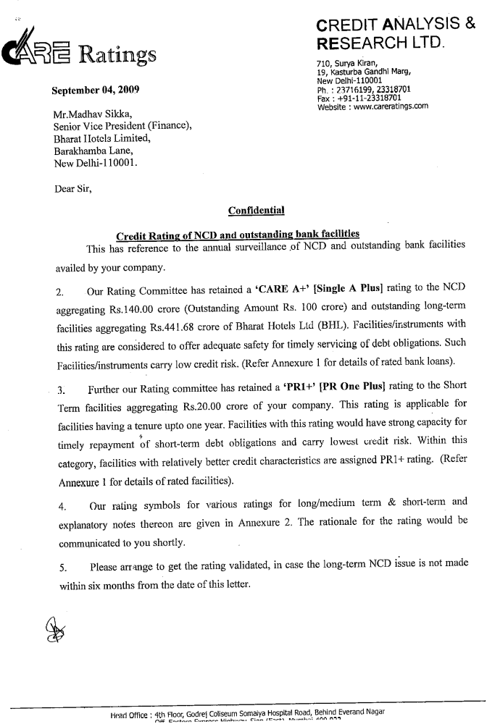

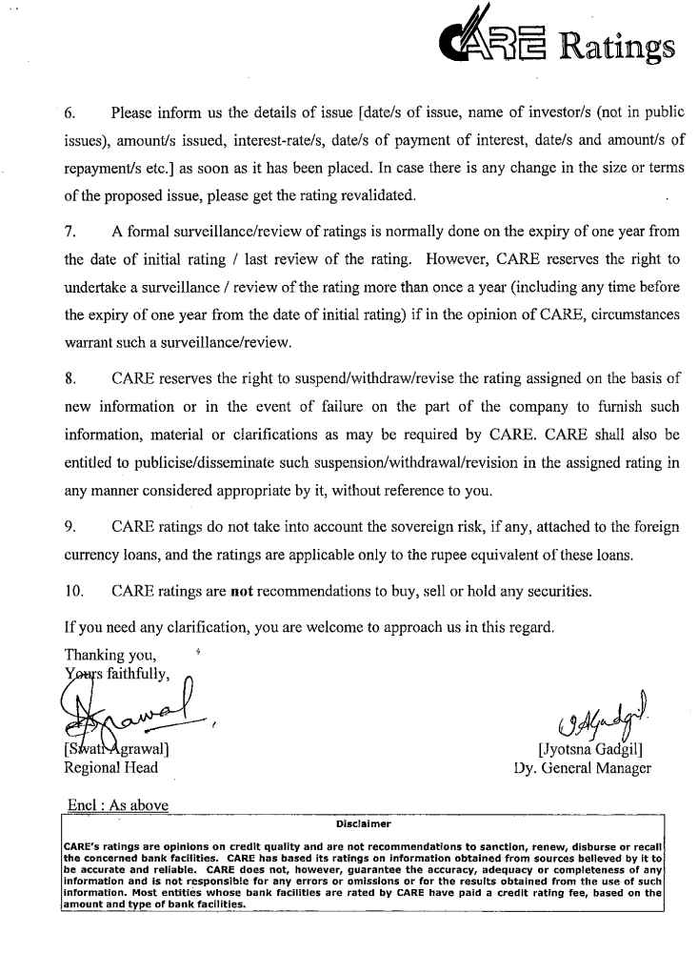
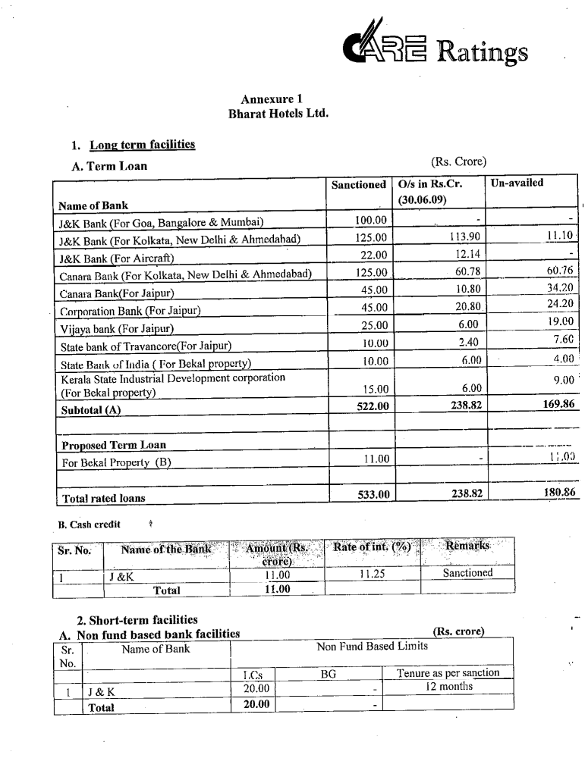
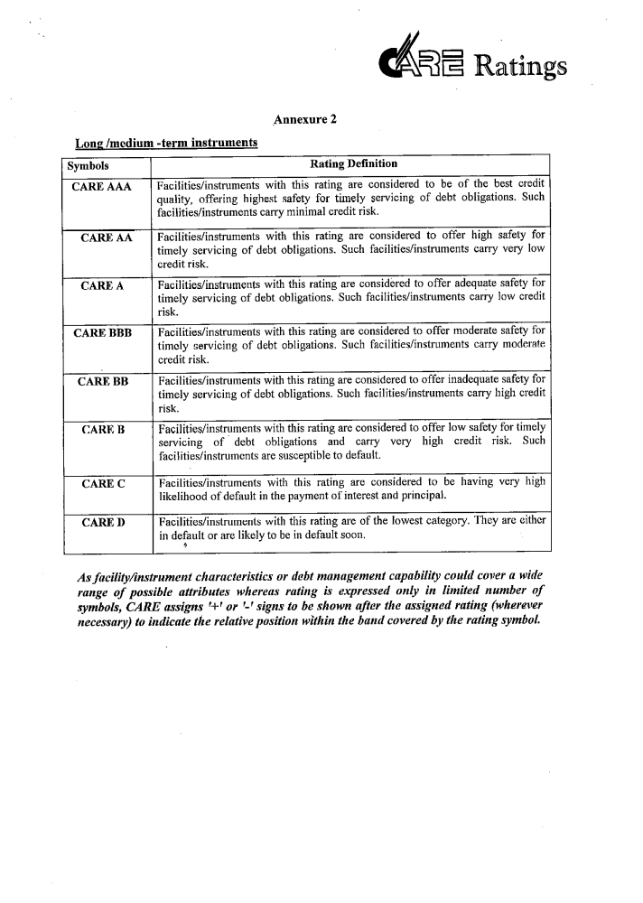
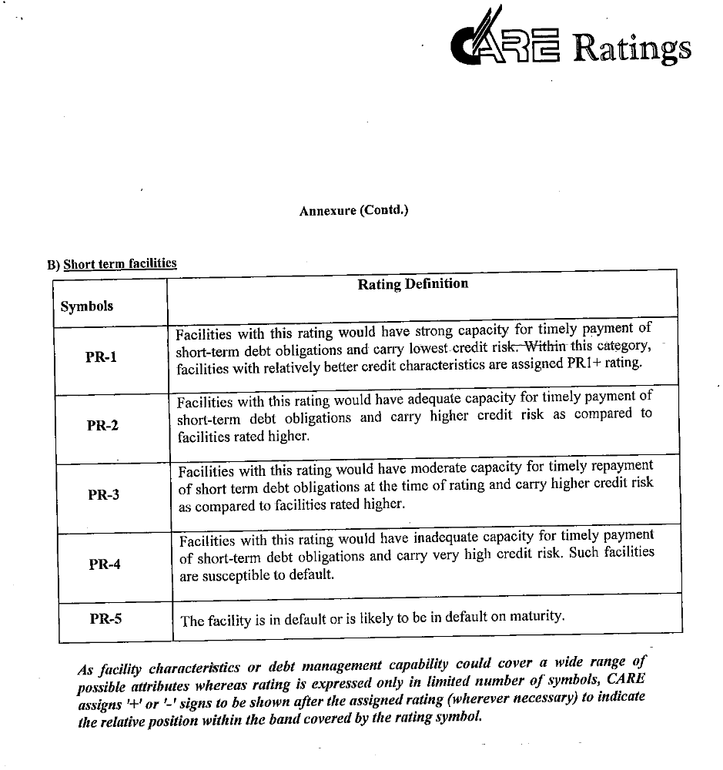

Annexure 2

Consent Letter from the Trustee



